**Fuji Film / DBL**

**King & Wood Mallesons**

**Digital Hub User Guide**

November 2024



**Revision History**

|  |  |  |  |
| --- | --- | --- | --- |
| **Date** | **Version** | **Description** | **Author** |
| 27th Feb 2024 | 1.0 | Initial Version | VR / JB / SA |
| 10th July 2024 | 1.1 | With all of the revisions and revised screens and functions | JB |
| 18th Sep 2024 | 1.1.1 | Added Multiple Package Function | AL |
| 23rd Oct 2024 | 1.2 | Added Toll/TGE booking steps | AL |
| 30th Oct 2024 | 1.2 | Added all scenarios related to courier bookings | AL |
| 25th Nov 2024 | 1.3 | Added Invoice Recon Function User Guide | AL |
|  |  |  |  |
|  |  |  |  |
|  |  |  |  |

# Table of Contents

1. Table of Contents 3

2. Introduction 5

2.1. Purpose 5

2.2. Scope 5

3. Logging Into the System 6

3.1. Logging Into the System 6

4. Creating Outbound Bookings (Hub Admins) 12

4.1. Creating an International/DHL Outbound booking from Scratch 12

4.1.1. Step 01 – Adding booking details 12

4.1.2. STEP 02 – Add Pickup Address 13

4.1.3. STEP 03 – Details of Items 15

4.1.4. STEP 04 – Cost Allocation 17

4.1.5. STEP 05 – Fill the Measurement details and the weight 18

4.1.6. STEP 06 – Select the Service “Find Couriers” 20

4.1.7. STEP 07 - Address & Shipment Details 21

4.1.8. STEP 08 - Pick up Time and Date 22

4.2. Creating an Inter-State & Intra-State Outbound Bookings – Toll/TGE, Star Track & Star Track Courier 23

4.2.1. STEP 01 – Details of Items 23

4.2.2. STEP 02 – Cost Center Allocation 25

4.2.3. STEP 03 – Insert Measurements 26

4.2.4. Adding Multiple Packages 27

4.2.5. STEP 04 – Next, click “Find Couriers” 28

4.2.6. STEP 05 – Address & Shipment Details 30

4.2.7. STEP 06 – Pick up Time and Date 31

5. How to Encode a Courier Booking - Steps for a User to create an Outbound booking 33

5.1. Save as a Draft 38

6. Label Print 39

7. Tracking progress of your Shipment 40

8. Processing a User Requested Booking 42

8.1. Choose bookings to process 42

8.2. Edit the booking 43

9. Processing a User Requested Booking – Toll/ TGE 46

9.1. Choose bookings to process 46

9.2. Edit the booking 48

9.3. Address & Shipment Details 51

9.4. Pick up Time and Date 52

10. Track & Trace 53

11. INVOICE RECON FUNCTION 55

11.1. Invoice Reconciliation Function 55

11.1.1. File Upload Validations 55

11.1.2. Upload Invoice Files 56

11.1.3. Multiple Lines Tab 58

11.1.4. Duplicated with Previous Invoices Tab 59

11.1.5. Unmatched Bookings Tab 60

11.1.6. Reconciling Booking with Amount Mismatches 61

11.1.7. Reconciling Unmatched Bookings 62

11.1.8. Reconciliation 63

# Introduction

This document is designed to provide users at King & Wood Mallesons the ability to understand the different functionalities offered by the Digital Mail Room product of the Digital Hub suite of products, by Drake Business Logistics, and to guide users through how to use these functions.

## Purpose

The purpose of the document is to give user a step-by-step guide on how to access the following functions using DHL:

* International Booking

## Scope

The scope of this document will be limited to the specific functionality made available to King and Wood Hub Admins who will use the system to book international documents and parcels using DHL as a carrier.

# Logging Into the System

## Logging Into the System

Login to the Digital Hub Platform:  
[**King & Wood Mallesons - Digital Hub (dbla.com.au)**](https://kwm.digitalhub.dbla.com.au/)

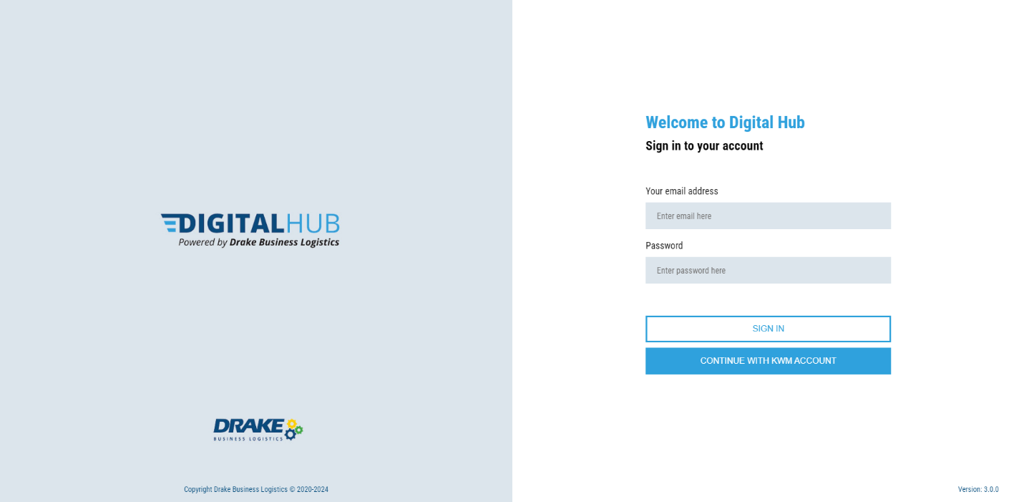

Enter your King & Wood email address and Click **Continue with  
KWM Account**.

The system will take you through to the home screen.

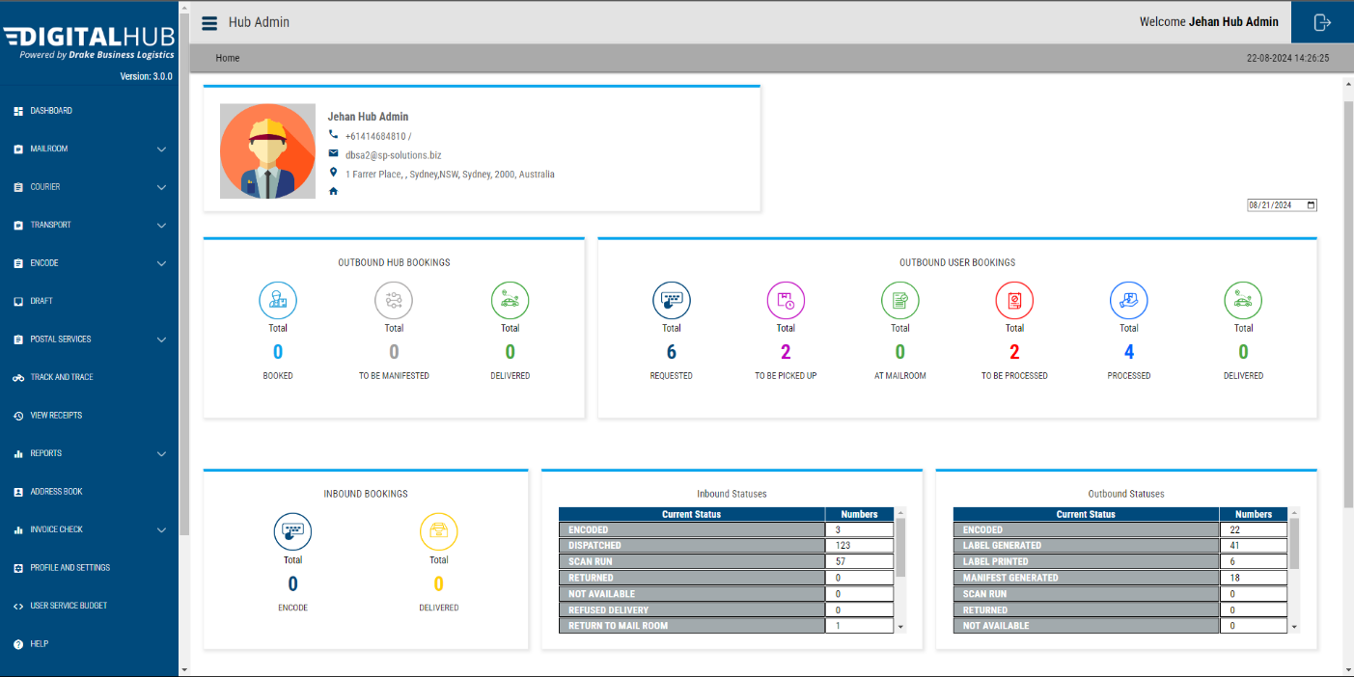

This is the main **Dashboard** that will give you an overview of all the ongoing activities.

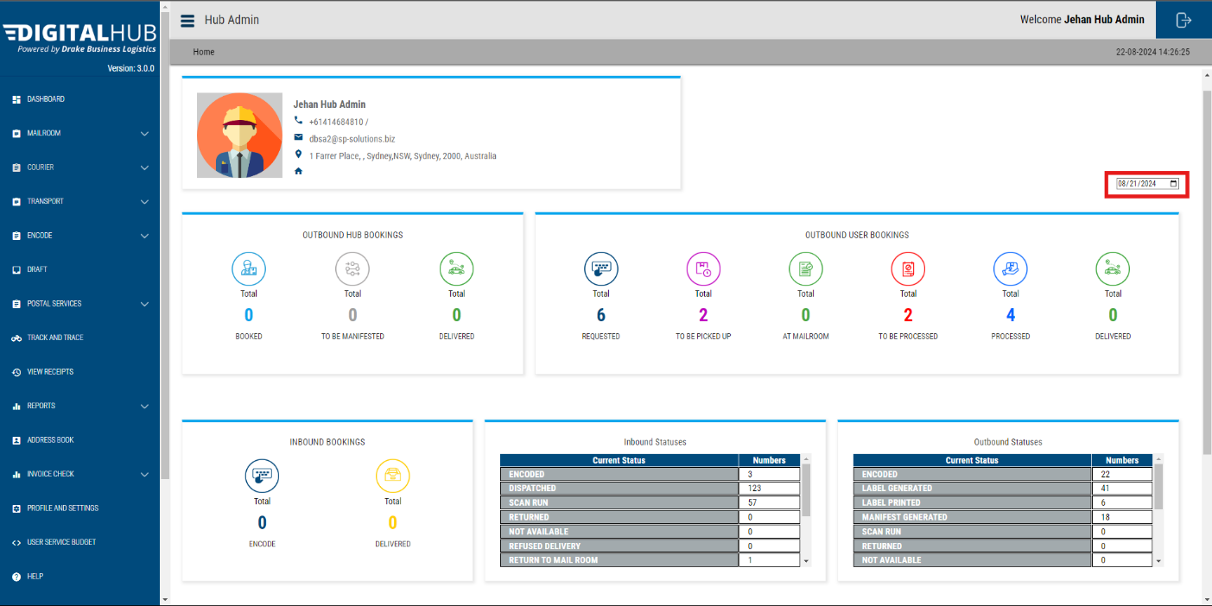

**Date Filter:**  You can use this filter to **select any date you wish** and see the details of that specific date.

**NOTE:** All the below dashboard counters will only show the details for the date selected by this filter.

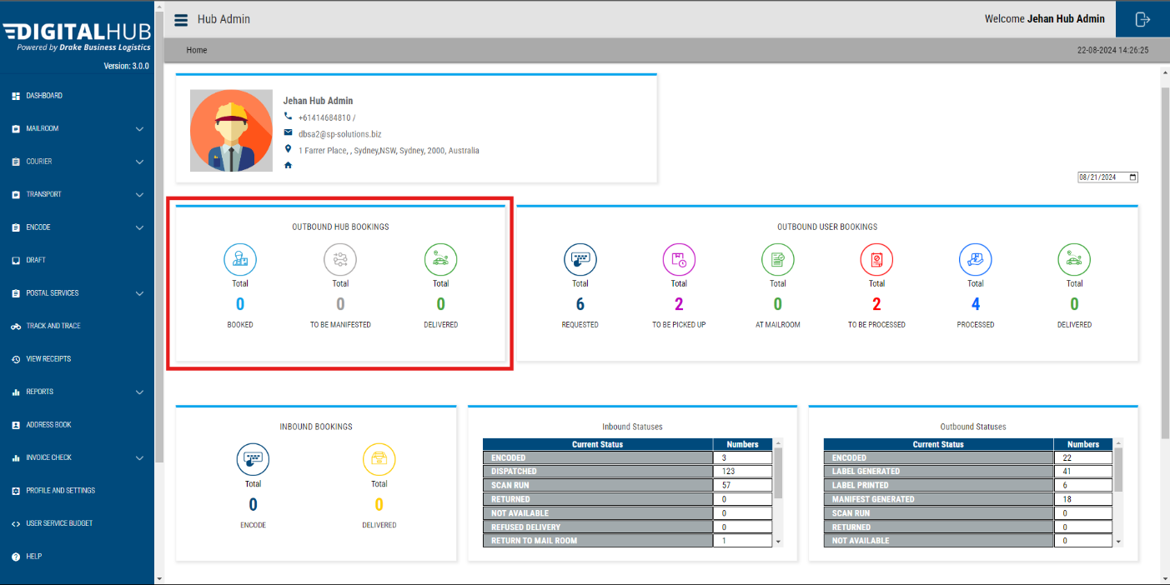

**Outbound Hub Bookings**

Here you can view the bookings that are directly put from a **Hub Admin** account from the **mailroom**.

**Booked** – total number of bookings created.

**To Be Manifested** – Label printed bookings that are yet to manifest.

**Delivered** – Total number of packages that have been delivered.

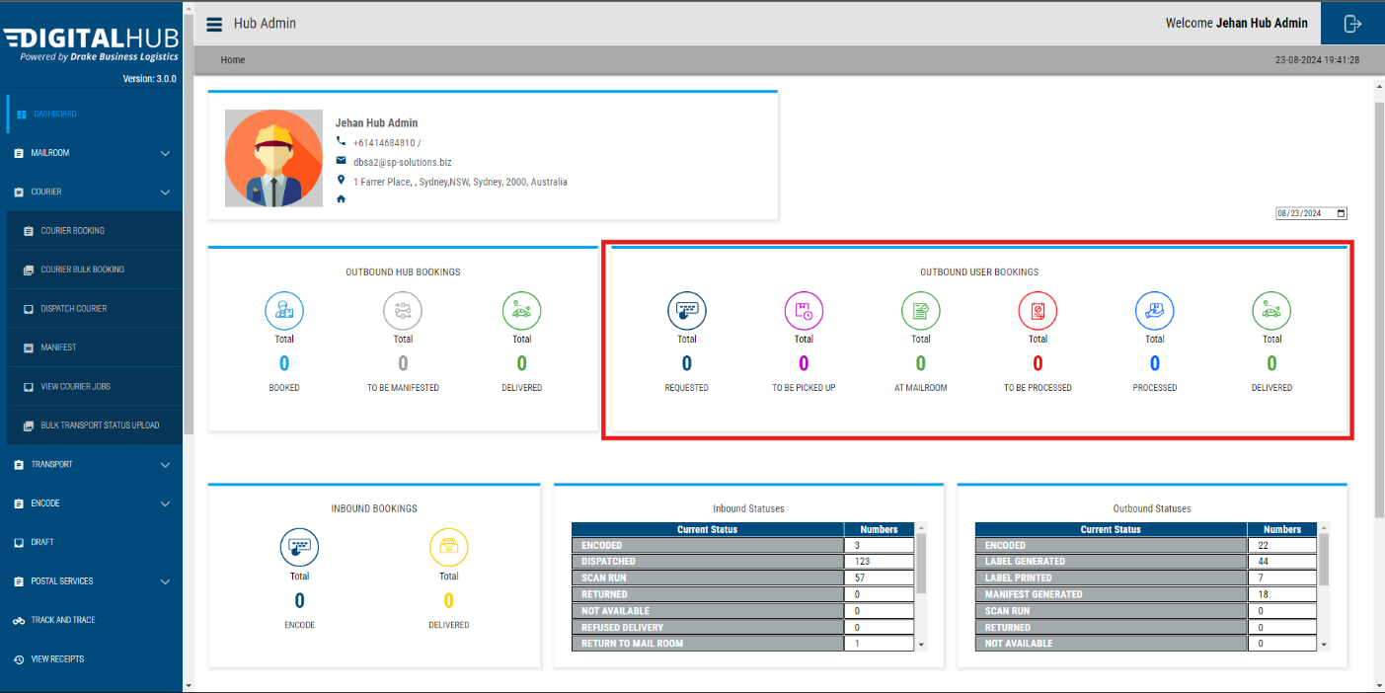

**Outbound User Bookings**

Here you can see an overview of outbound bookings that are booked by users.

* **Requested** – Total number of bookings that were created by the users.
* **To Be Picked Up** – Number of packages that is yet to be picked up from the sender (users).
* **At** **Mailroom** – Number of packages that have been bought down to the mailroom
* **To Be Processed** – Number of bookings that need to be attended
* **Processed** – Number of bookings attended and done printing labels.
* **Delivered** – Bookings that have been delivered

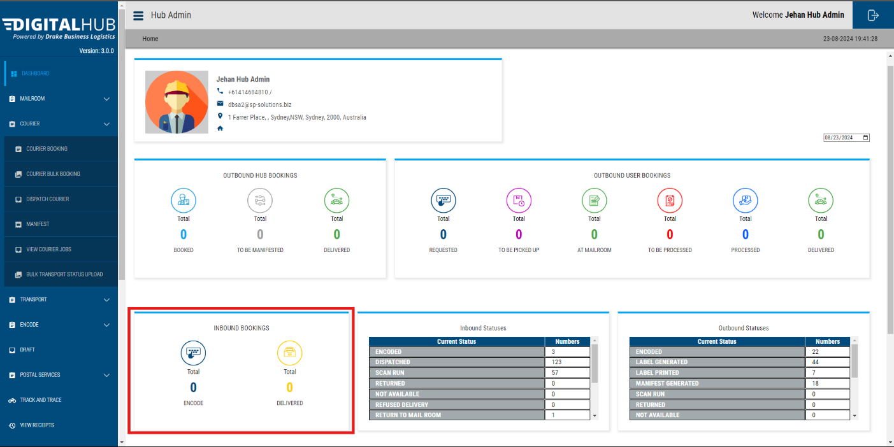

**Inbound Bookings**

This dashboard section shows an overview of all the messenger jobs.

* **Encoded** – All the packages that are received to the mailroom by a courier, that need to be taken to the specific person.
* **Delivered** – Number of all the packages that have been successfully taken to recipients.

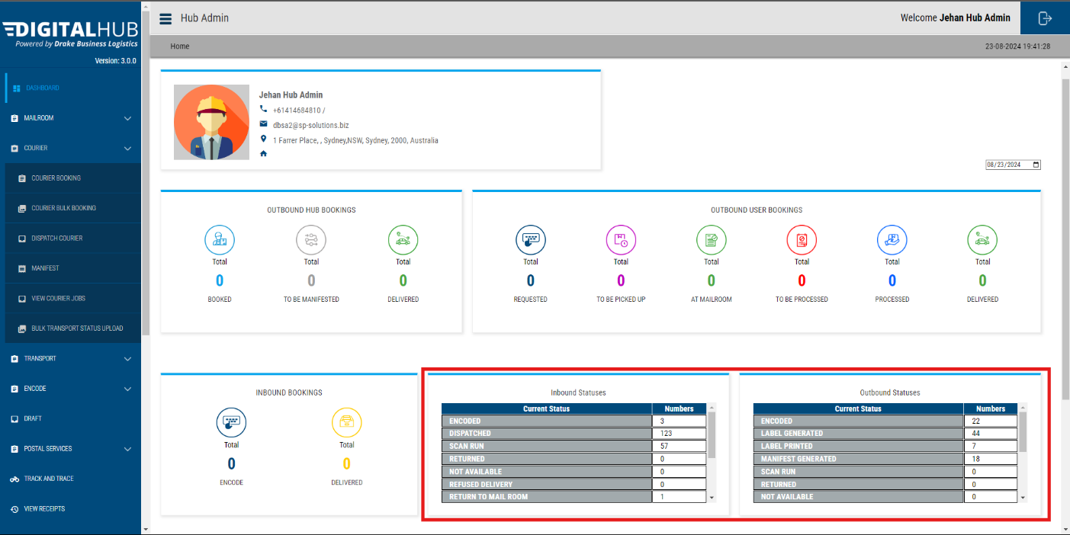

**Inbound Statuses & Outbound Statuses**

* These Statuses show all the booking details in the past. Use the scroll wheel to see more statuses.

# Creating Outbound Bookings (Hub Admins)

## Creating an International/DHL Outbound booking from Scratch

### Step 01 – Adding booking details

Click on the **Courier** Tab.

When the accordion opens out, select **Courier Booking** – the below interface will open up.

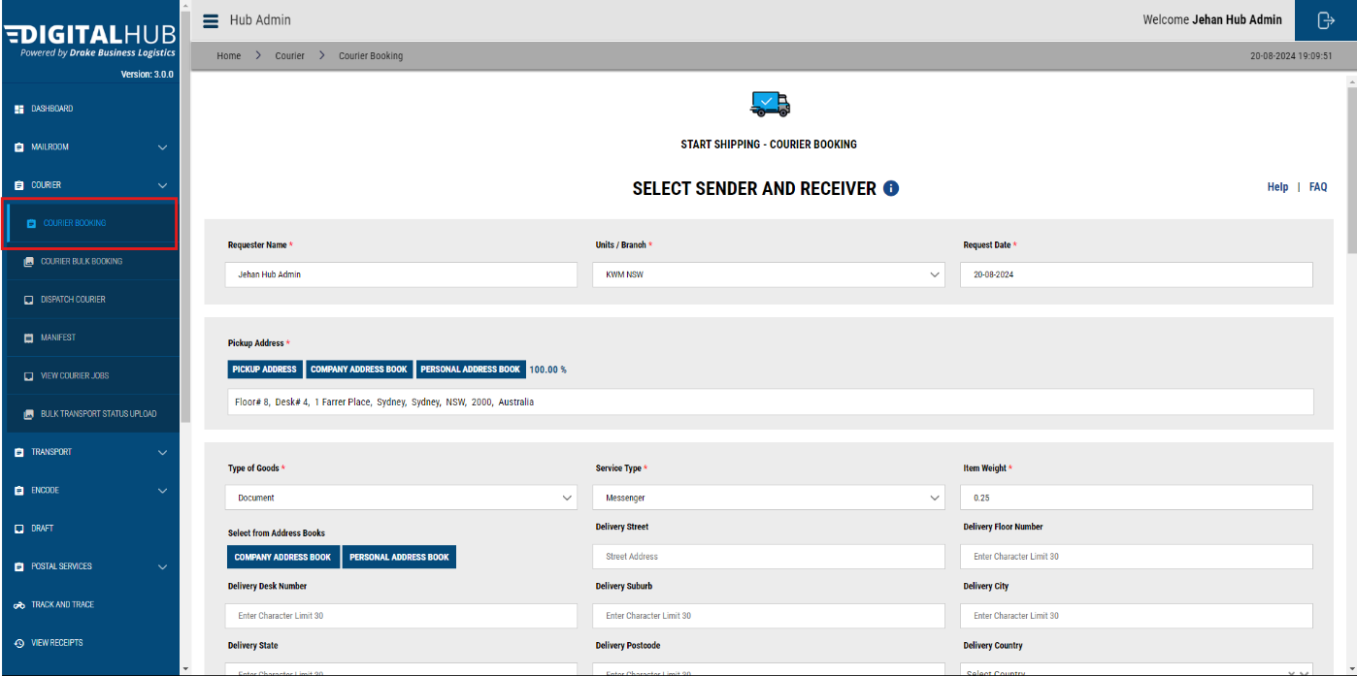

Check that your details are displayed accurately in the requester details.

Make sure the Pickup Address is correct as well. If not, you can choose either the **Company Address Book** or **Personal Address Book** and easily add the pickup address.

### **STEP 02 – Add Pickup Address**

Then, add the pickup location.

* You can type it in using the **Pickup Address** Tab – this is interfaced with google to validate address and will prompt addresses based on Google maps recognition.
* Use the **Company Address Book** – search for a user desk, a pickup point on any of the KWM floors in your building. Click **Search** to find and tick to select.

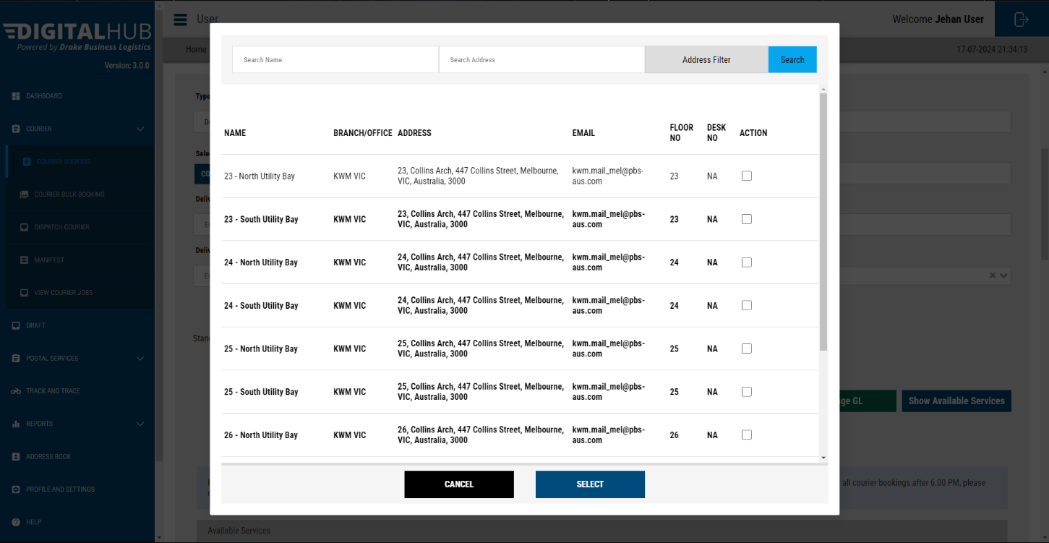

* Use your **Personal Address Book** – which will have your frequently sent addresses which may not be a part of the company address book. Click **Search** to find and tick to select.

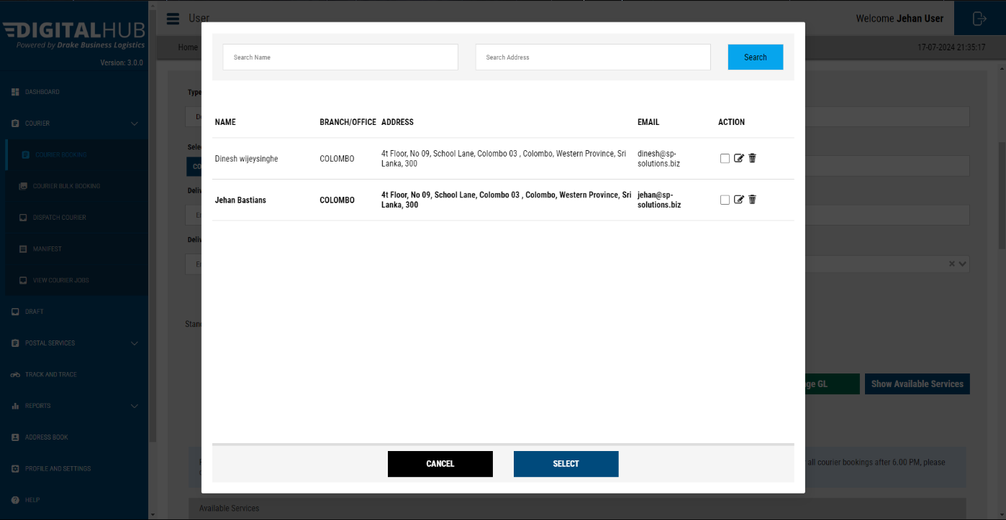

**Please note: If you select a floor other than the 8th floor (which houses the mail room) – a messenger will be assigned to come pick it up.**

### STEP 03 – Details of Items

Then, select the details of the items you wish to send.

* Documents
* Parcel

You can type out the delivery address in the **Deliver Street** field and the system will integrate with Google and display matching addresses which you may select. On selecting, the UI will auto complete.

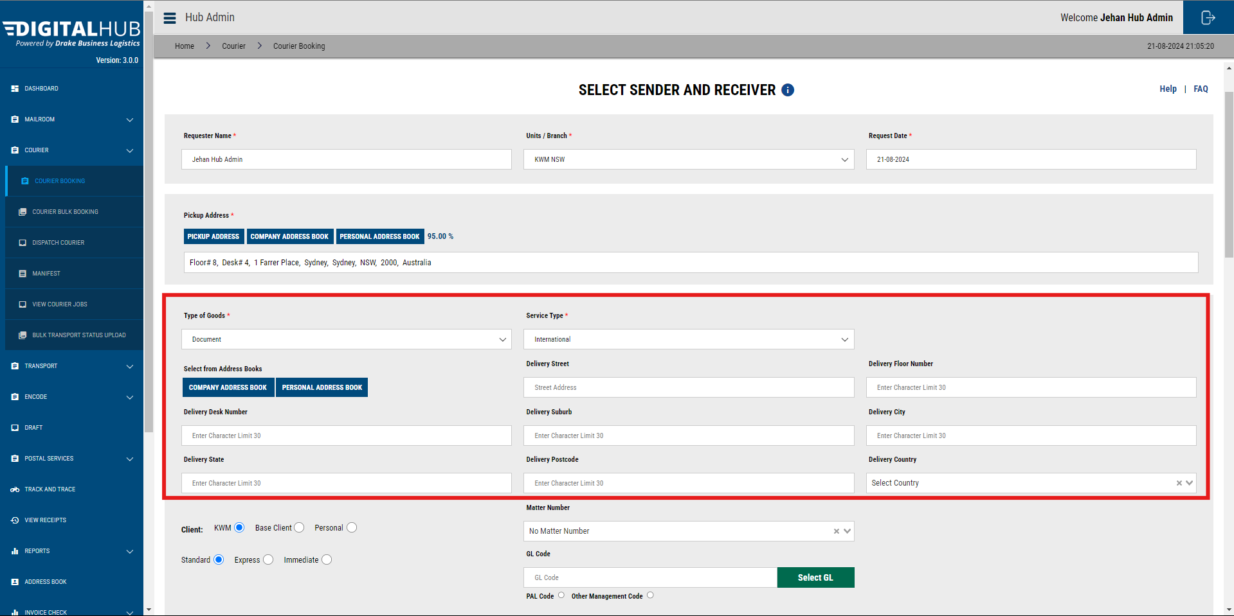

You may select the delivery address from address books(Personal / Company).

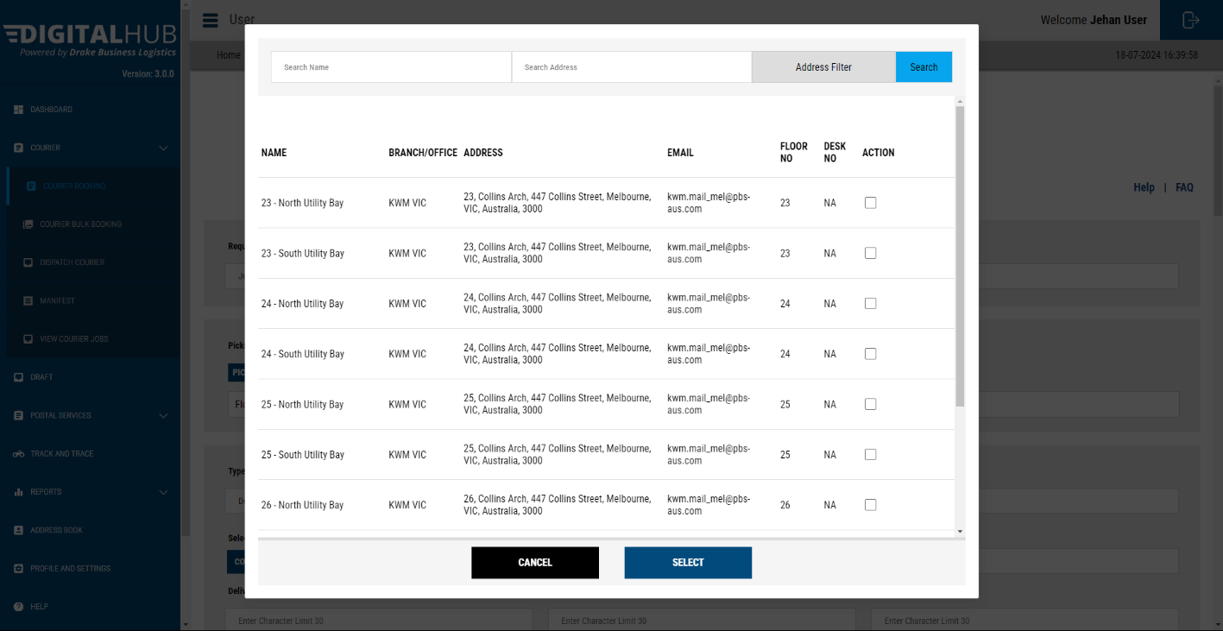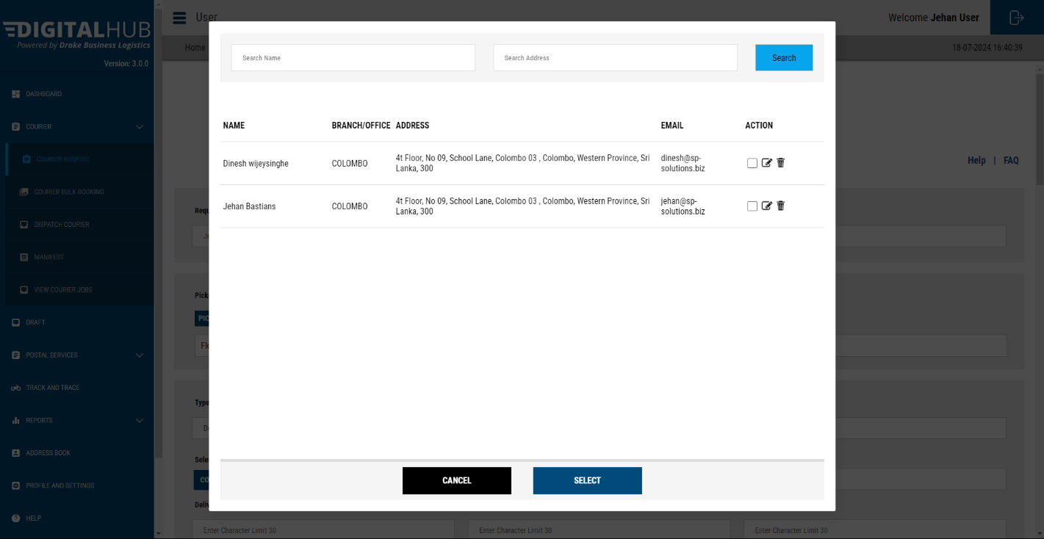

### STEP 04 – Cost Allocation

Please add the **Matter** **Number** or the **GL Code** number.

The matter number is a type search list updated daily based on the matter numbers provided.

You can select the same, or you can change the GL code by clicking on the **Select GL** button.

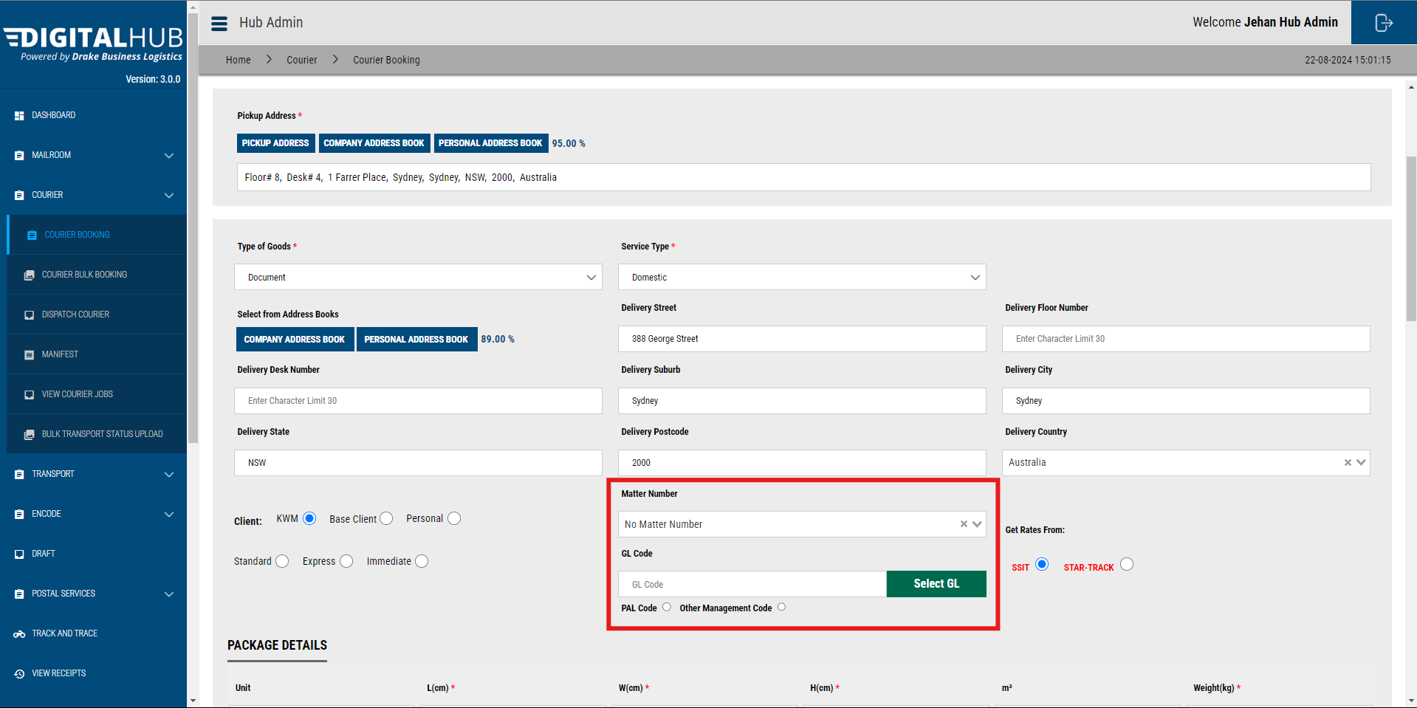

### STEP 05 – Fill the Measurement details and the weight

#### For ‘Type of Goods’ : Documents

Firstly, fill **‘Item’** field with accurate measurements of the item.

Then fill **‘Package’** field with the accurate measurements (Width, Height, Length and Weight) of the package. Measurements that are being added to Package field must be equal or higher than what is in the relevant Item field.

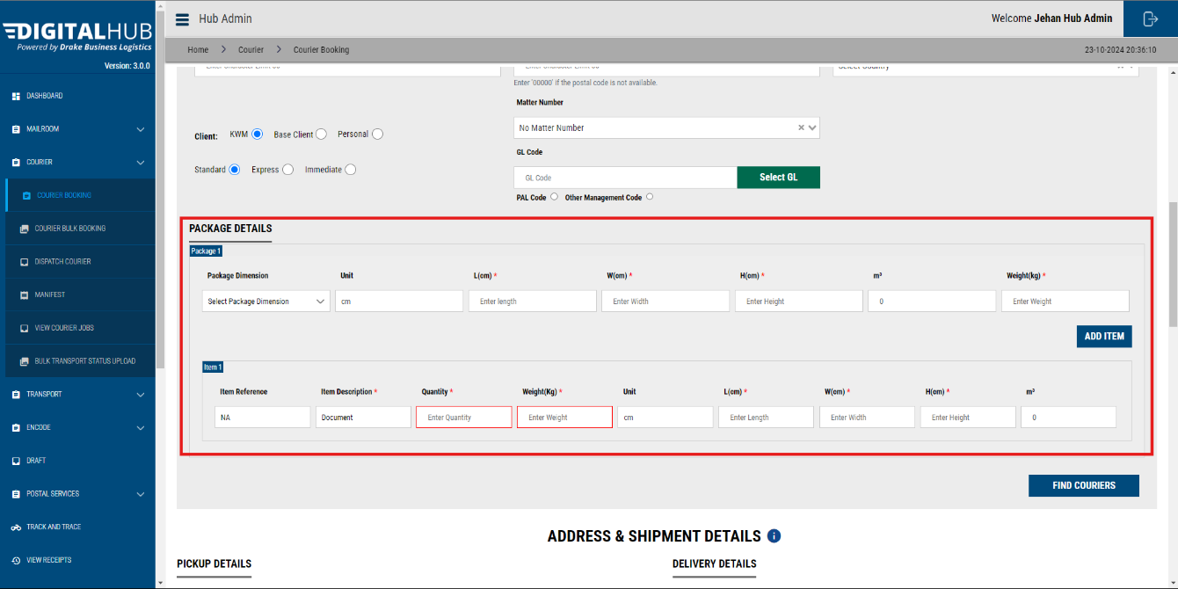

#### For ‘Type of Goods’ : Parcel

Firstly, fill **‘Item’** field with accurate measurements of the item.

Then fill **‘Package’** field with the accurate measurements (Width, Height, Length and Weight) of the package. Measurements that are being added to Package field must be equal or higher than what is in the relevant Item field.

For Parcels you are required to add;

**Commodity Code Value :** You are required to create an account on the [DHL MyGTS](https://mygts.dhl.com/login) site and get **Tariff Codes** relevant to the item in the package.

**Customer Reference Type Code:**

**Customer Reference Code Value:**

**Commercial Value:**

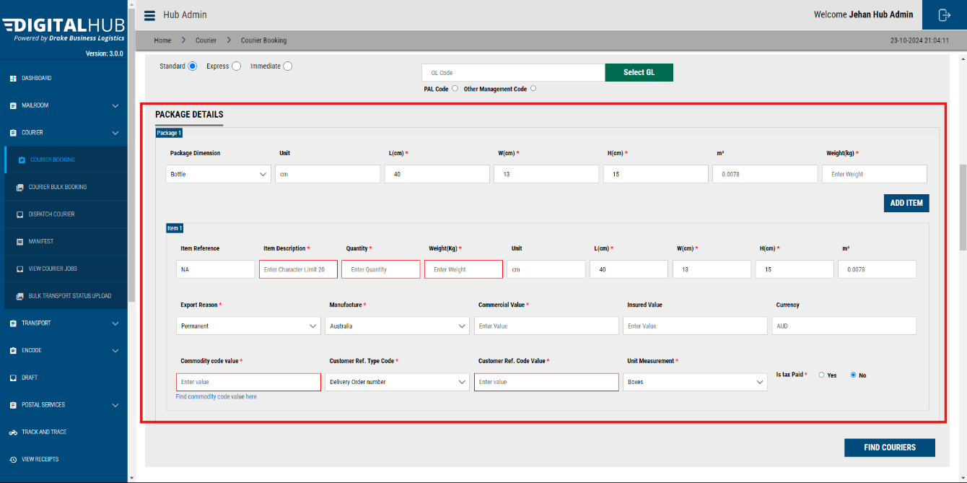

### STEP 06 – Select the Service “Find Couriers”

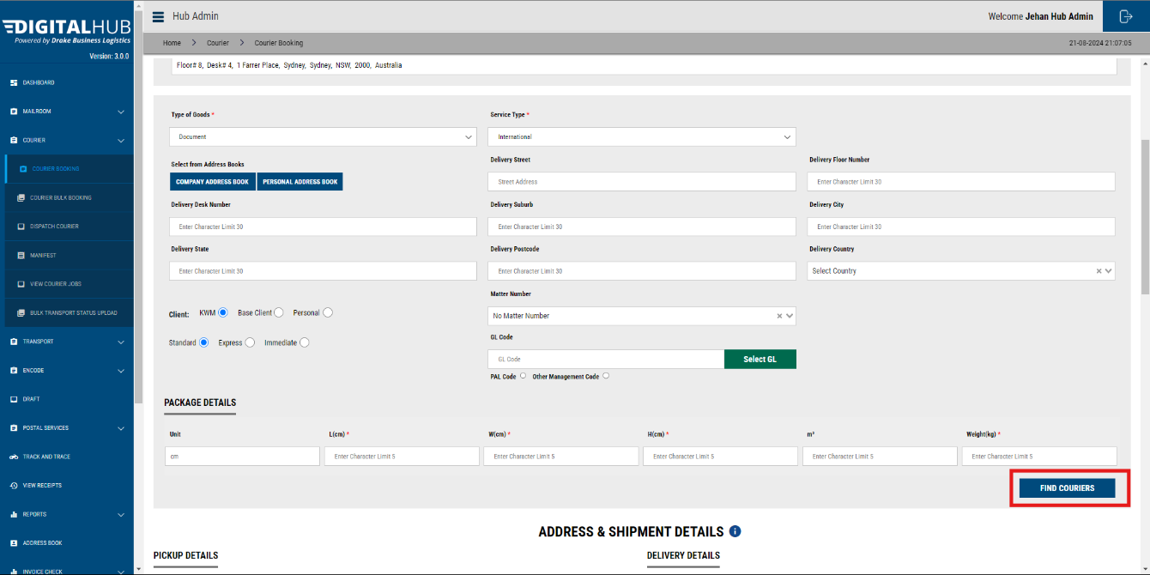

Click on the **“FIND COURIERS”** button, then the system will show you **available services for your booking** – Please select your preferred services based on your urgency and scroll down.

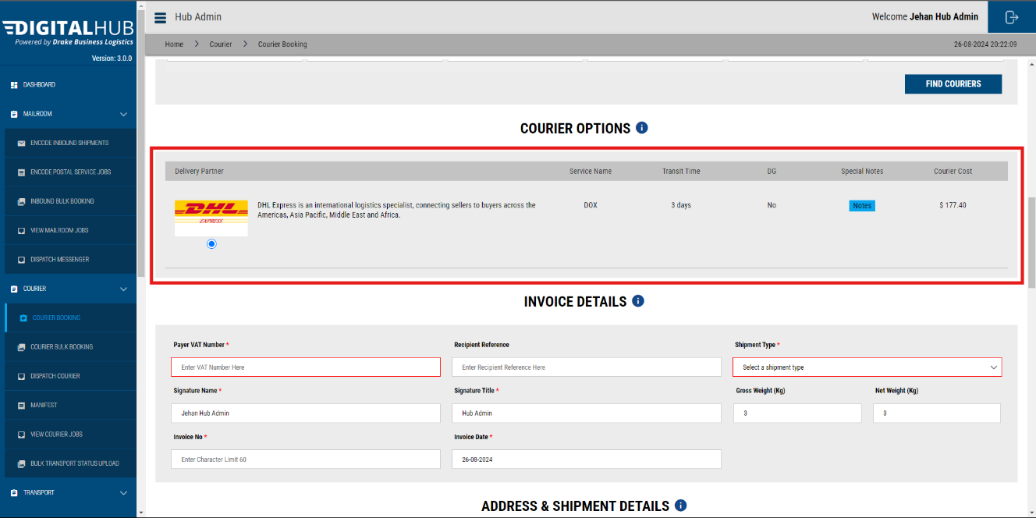

### STEP 07 - Address & Shipment Details

Here you need to add the receivers’ Name, Company Name, Email, & Phone number.

**Address details** will be filled in **automatically**.

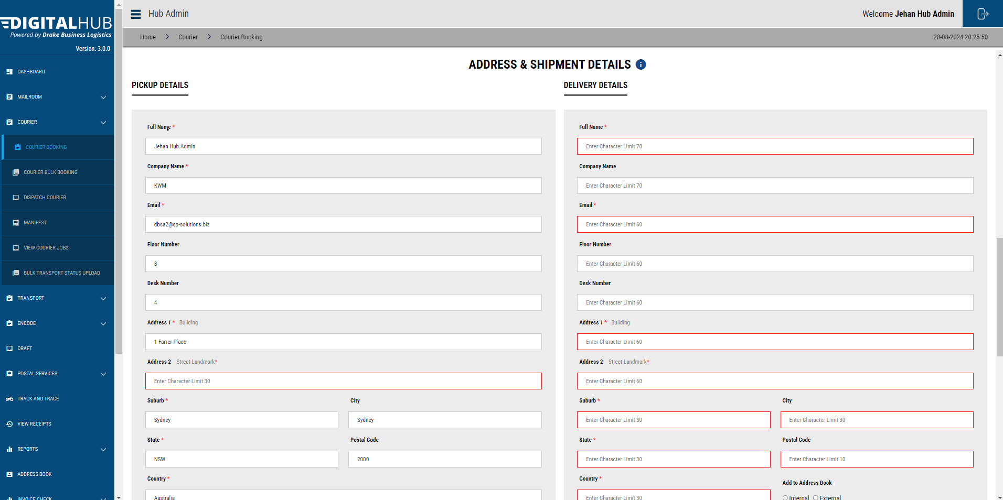

If there is no **Address Line 2**, please add what is in the **Suburb Field** in the **Adress Line 2** field as well.

### STEP 08 - Pick up Time and Date

Update the **Pickup Date**, & **Time**. This should always be a time in the future.

Additionally, you may add the **Office Closing time** too.

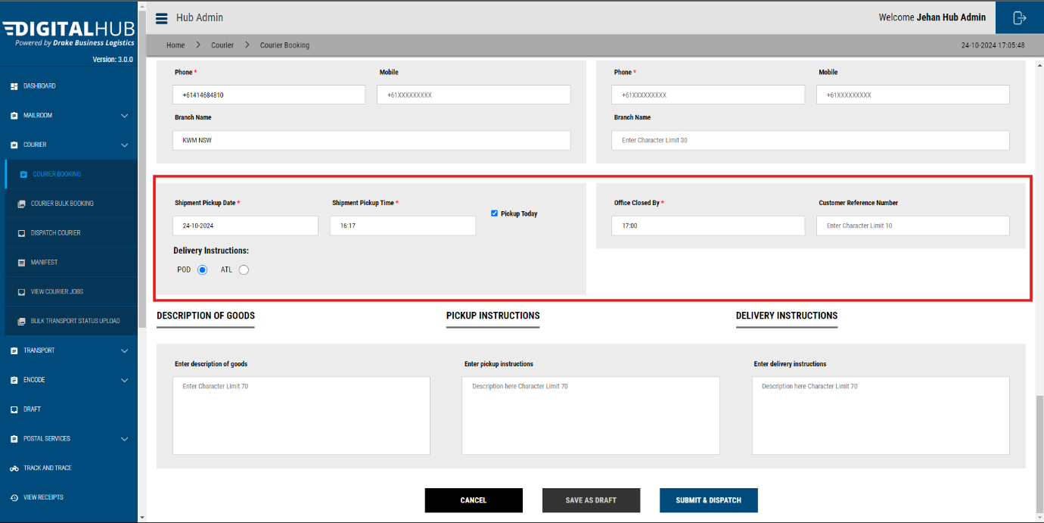

Moreover, admins can add a choice for **POD** ( Proof of delivery) vs **ATL** ( Authority to Leave).

You may add any additional instructions in the given fields.

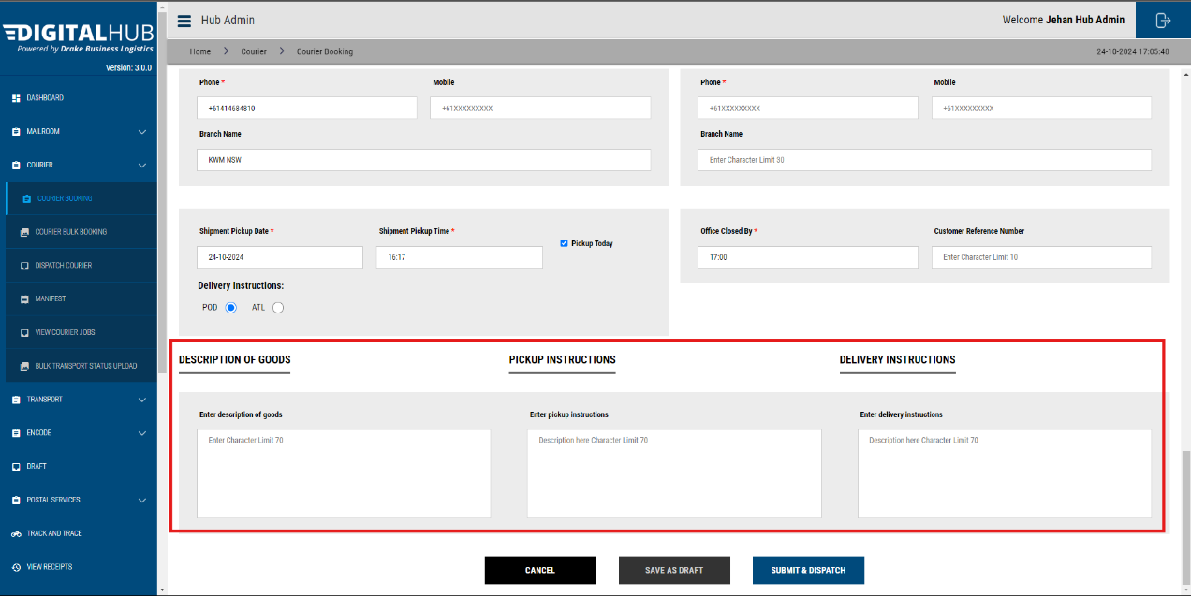

Click **Submit & Dispatch**. Your booking will be created.

You will be redirected to the **View Booking** page.

## Creating an Inter-State & Intra-State Outbound Bookings – Toll/TGE, Star Track & Star Track Courier

**Toll/ TGE** services are used for Inter-state couriers.(1-2 Business Days)

**Star Track** services are used for Intra-state couriers. (1-2 Business Days)

**Star Track Courier** are used for Intra-state immediate couriers. (1-3 hours)

### STEP 01 – Details of Items

Then, select the details of the items you wish to send.

* Documents
* Parcel

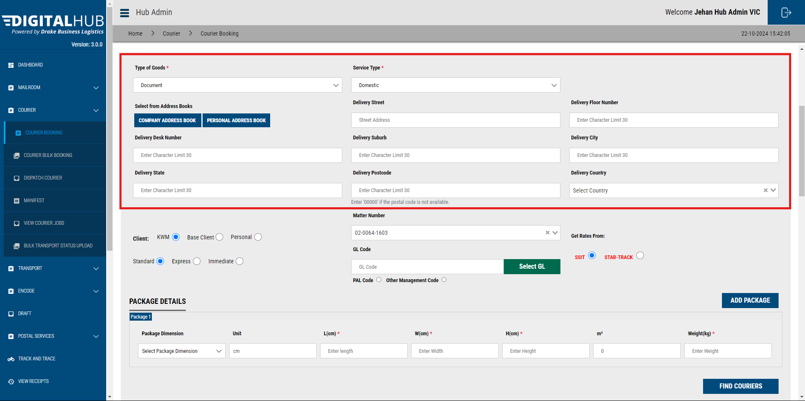You can type out the delivery address in the Deliver Street field and the system will integrate with Google and display matching addresses from which you may select. On selecting, the UI will auto populate.

You may select the delivery address from address books(Personal / Company).

**Company Address Book**



**Personal Address Book**



You have the choice of adding a completely new address as well.

### STEP 02 – Cost Center Allocation

Please add the **Matter** or the GL Code number.

The matter number is a type search list updated daily based on the matter numbers provided.

You can select the same, or you can change the GL code by clicking on the **Select GL** button.

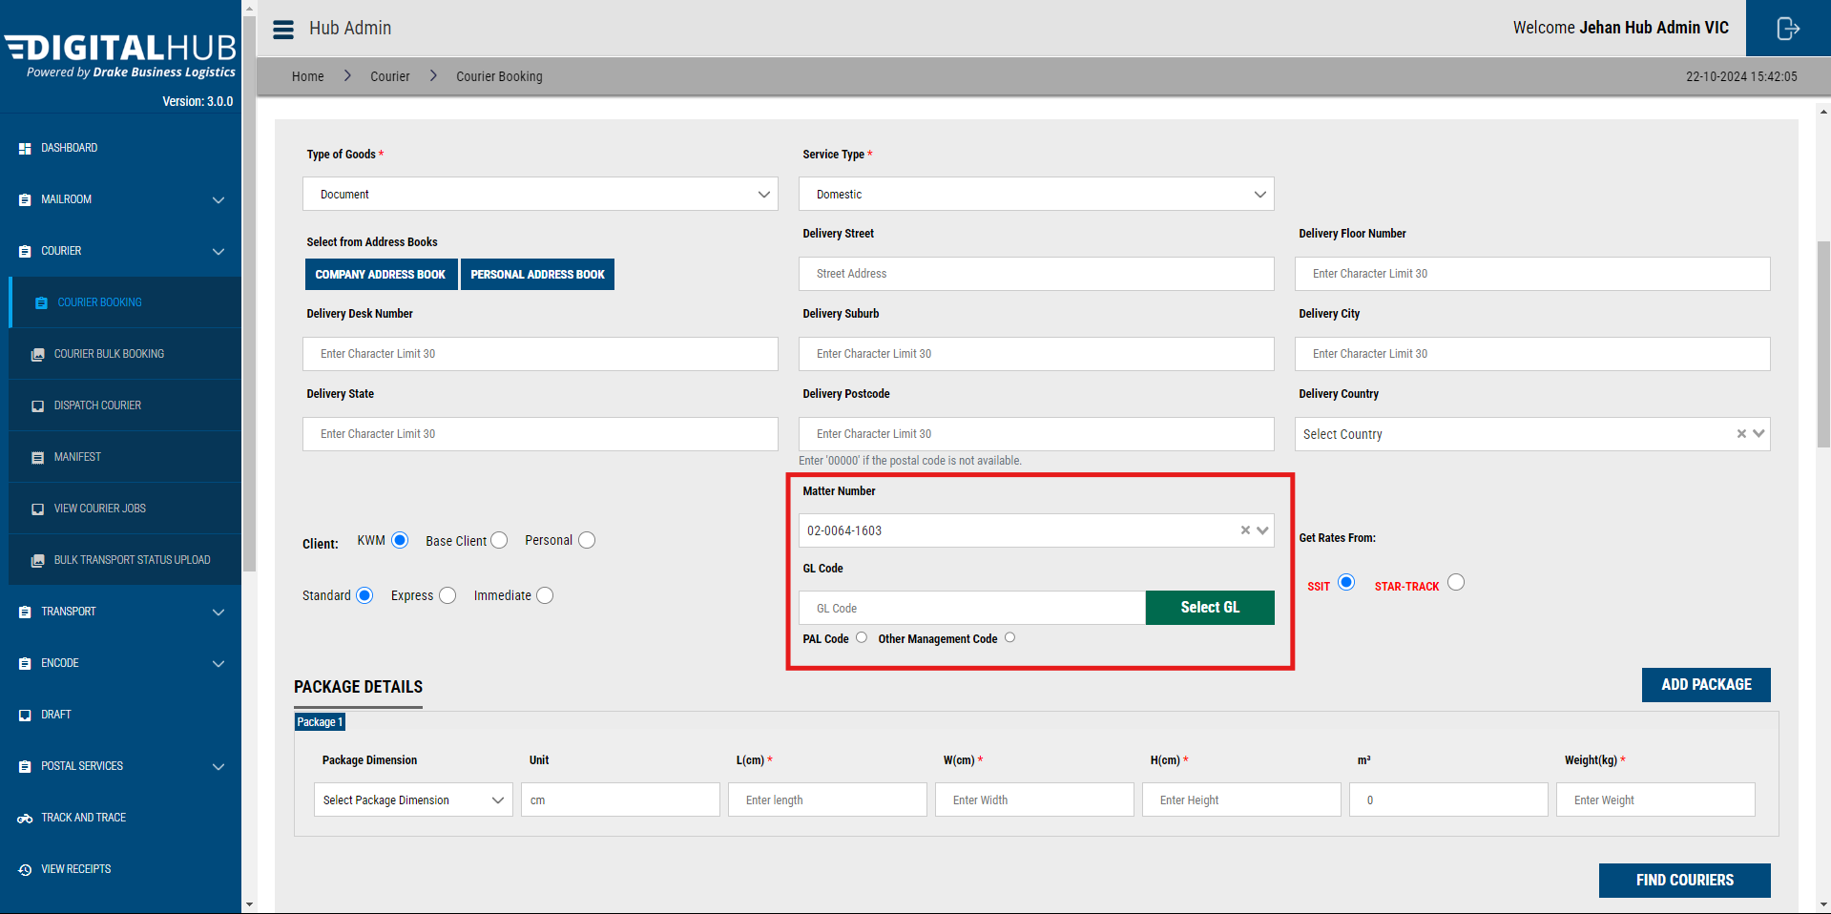

### STEP 03 – Insert Measurements

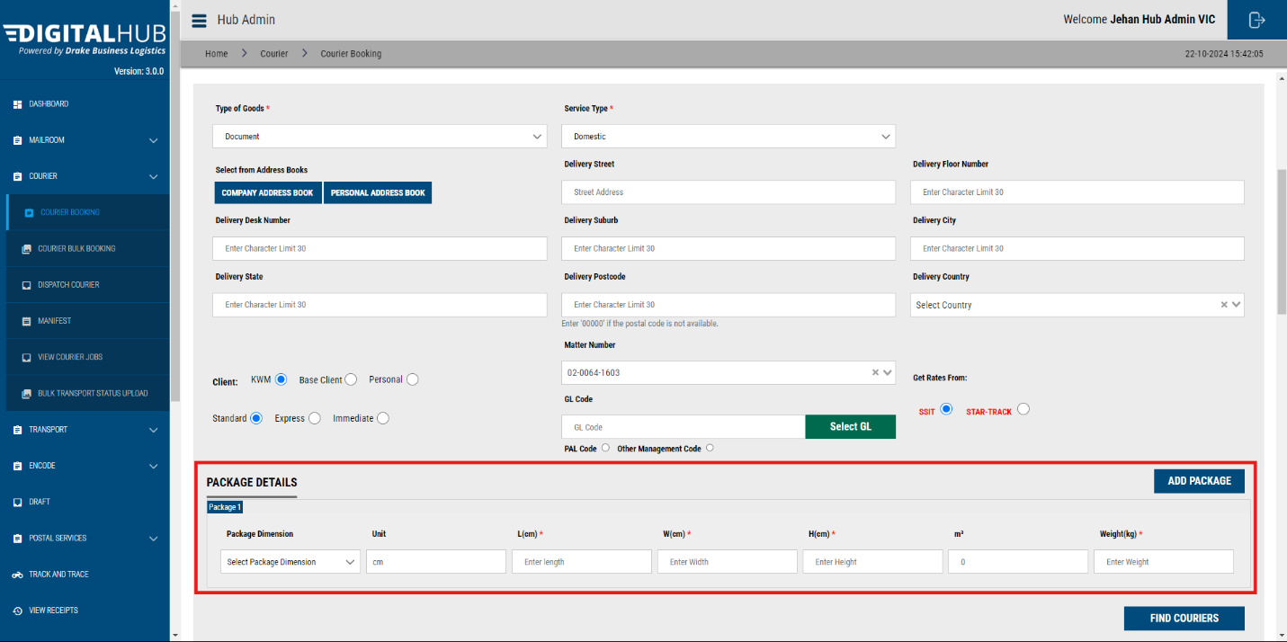

Add the package measurements & the weight.

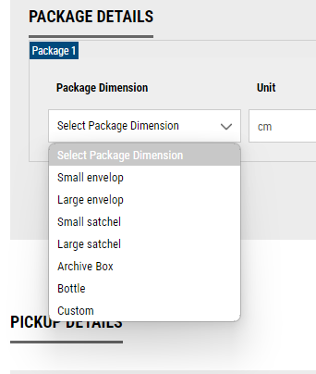

By clicking on the Package Dimension dropdown, you will be able to select from a list of frequently used package types. Once selected, dimensions relevant to those packages will auto-populate.

If you need to add a custom weight, please choose **‘Custom’.**

### Adding Multiple Packages

If you wish to add multiple packages in one shipment, click on the **‘Add Package’** button.

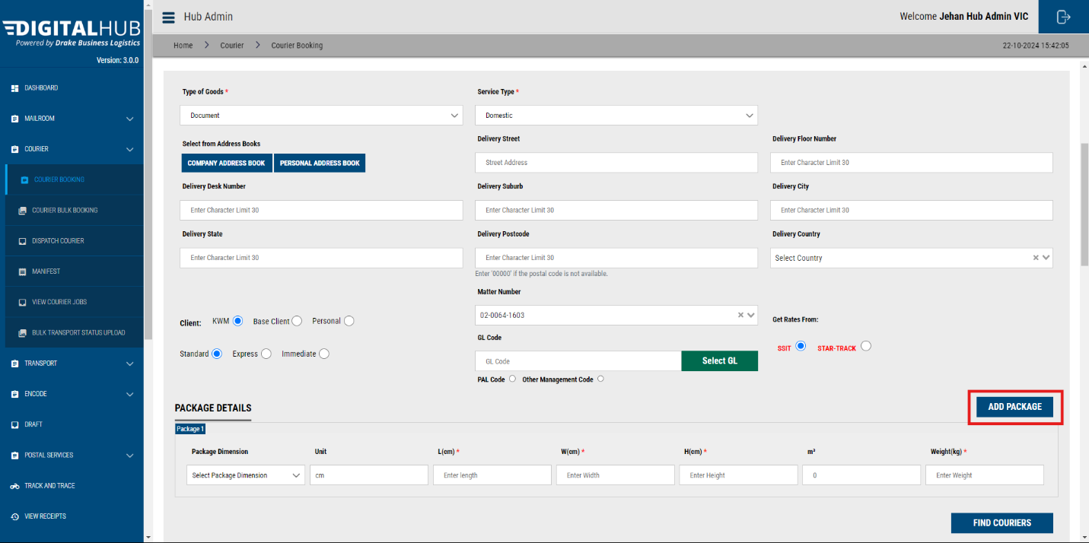

A new field will be added.

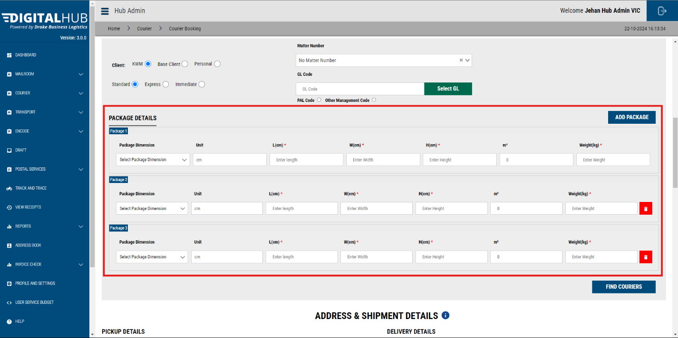

Then you may add the dimensions.

### STEP 04 – Next, click “Find Couriers”

Select **SSIT (Starshipit)** option for **Toll/ TGE.**

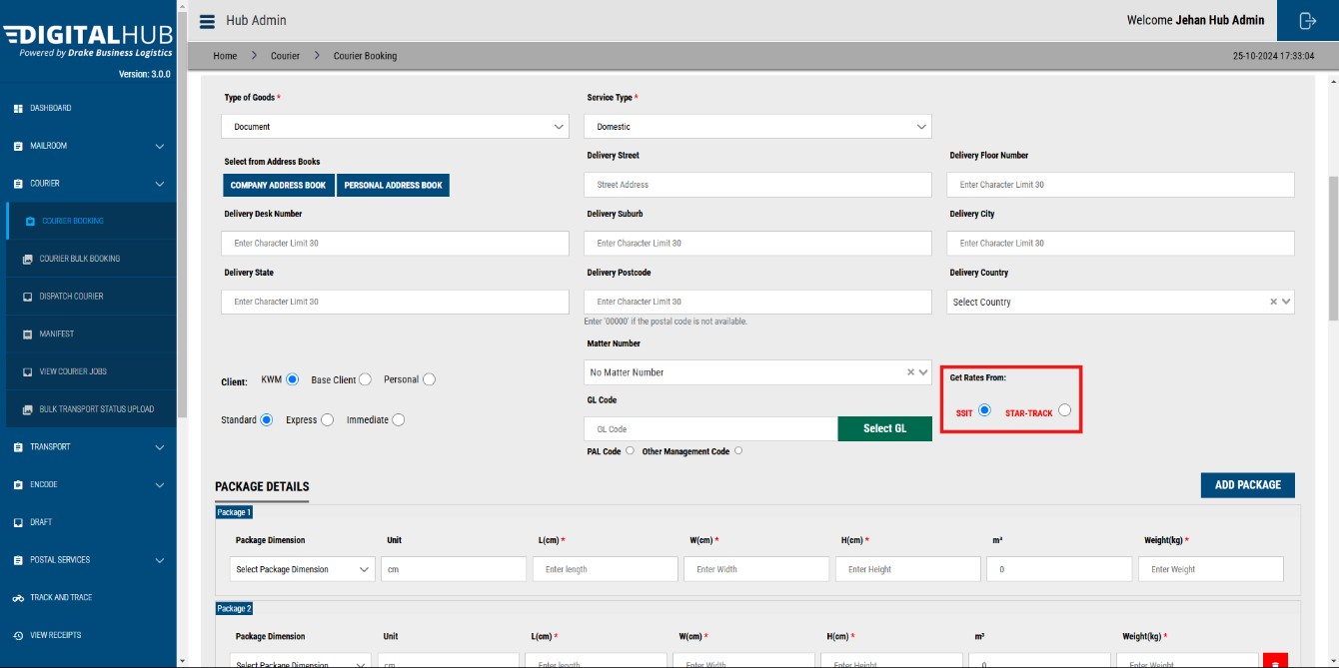Select **Star Track** for all **Star Track services.**

Click on the **‘Find Couriers’**, button.

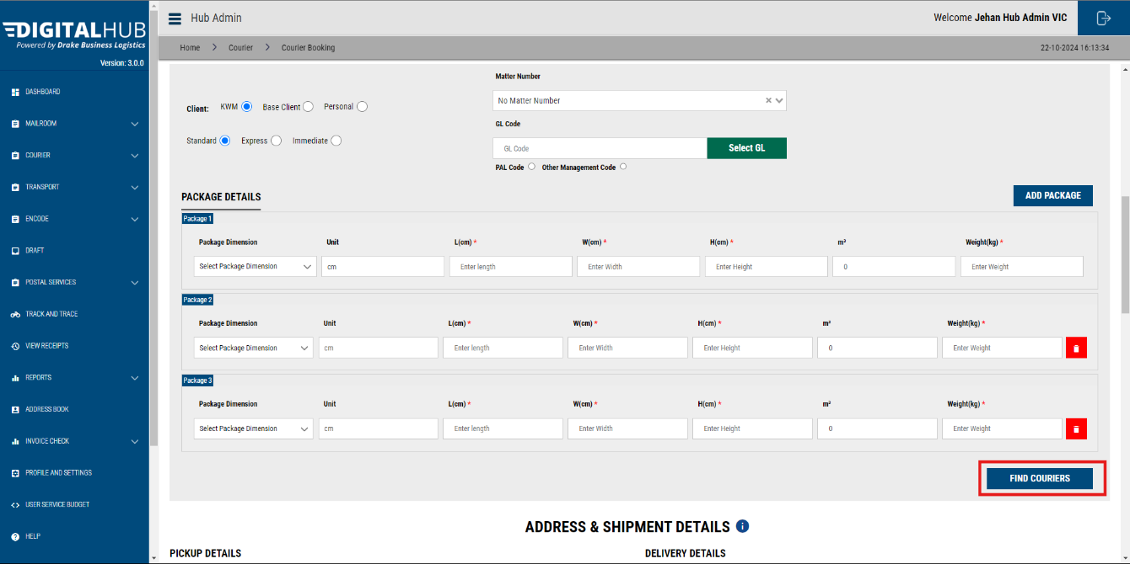

The system will show you **available services for your booking** – Please select the preferred Toll/TGE service based on your urgency and scroll down.

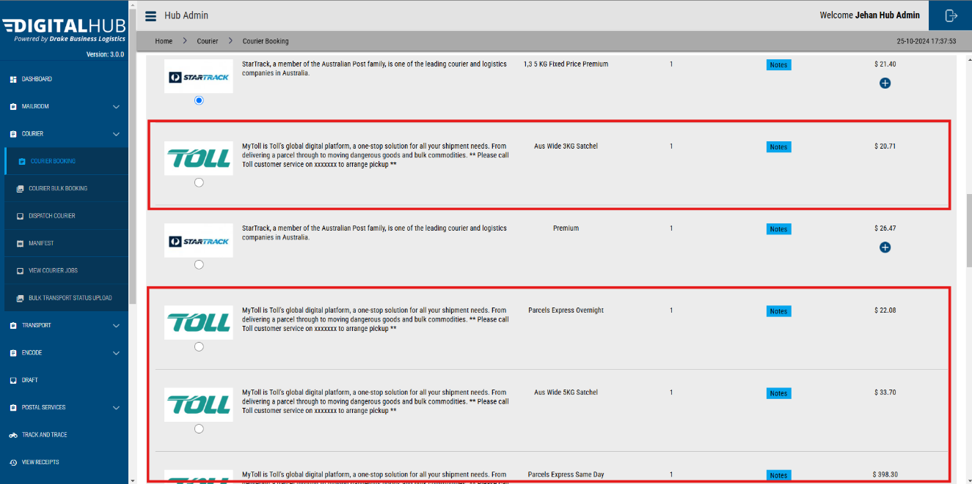

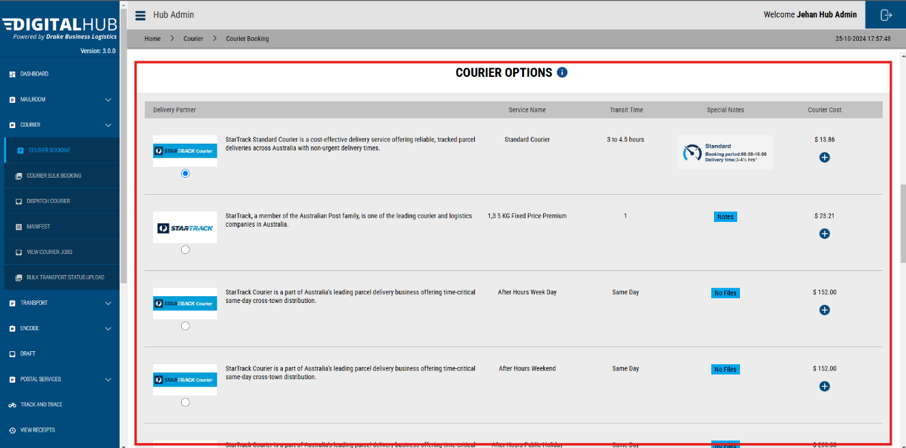

### STEP 05 – Address & Shipment Details

Here you need to add the receivers Name, Company Name, Email, & Phone number.

Address details will be filled in automatically.



### STEP 06 – Pick up Time and Date

Update the pickup date, & time.

Additionally, you can add the Office Closing time too.

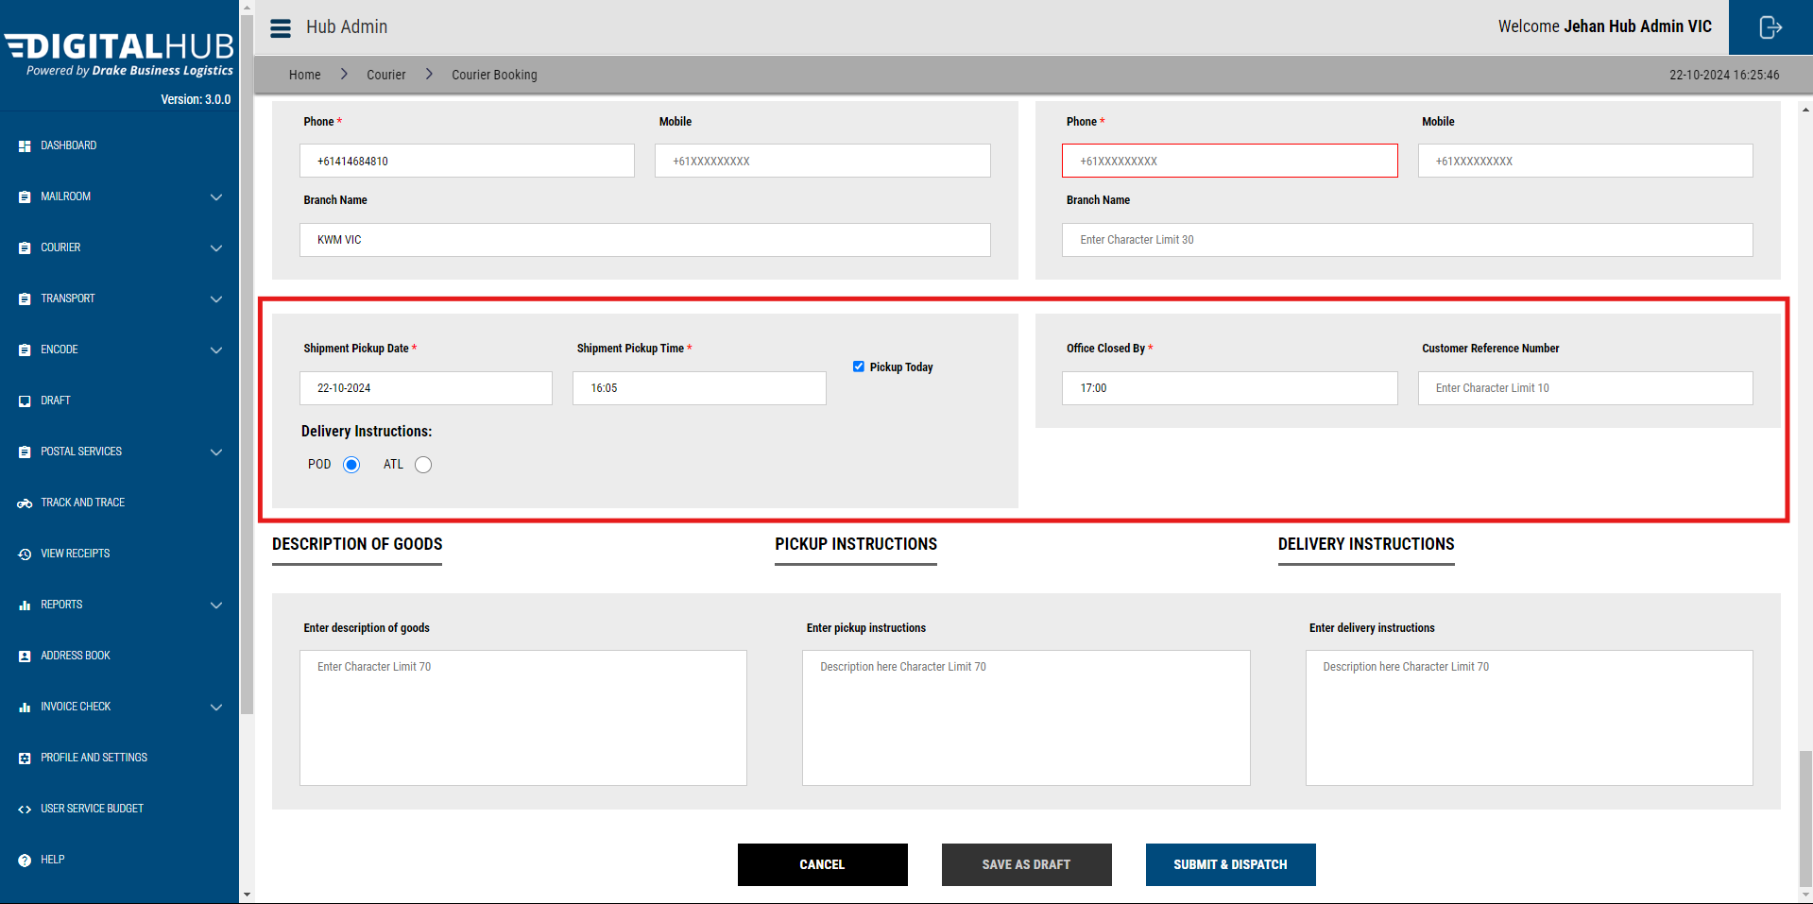

You may choose between ATL ( Authority to Leave) vs POD (Proof of Delivery)

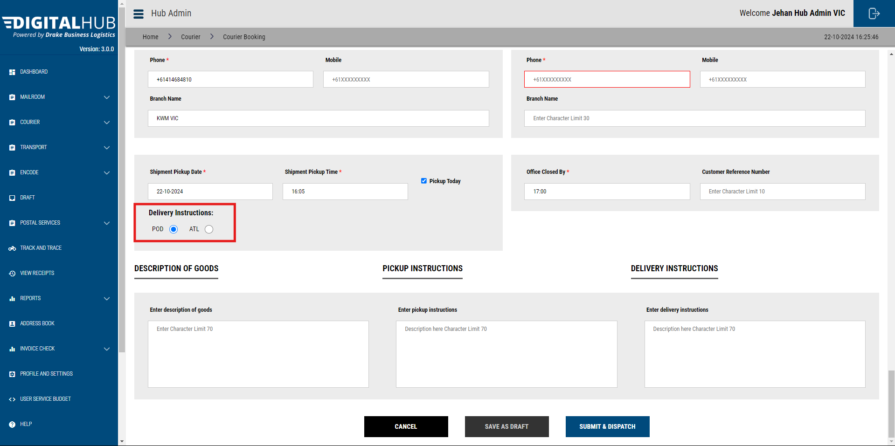

You may add any additional instructions/ comments in the given fields. 

Click **Submit & Dispatch**. Your booking will be created.

You will be redirected to the **View Booking** page.

# How to Encode a Courier Booking - Steps for a User to create an Outbound booking

Firstly, Login to the System.

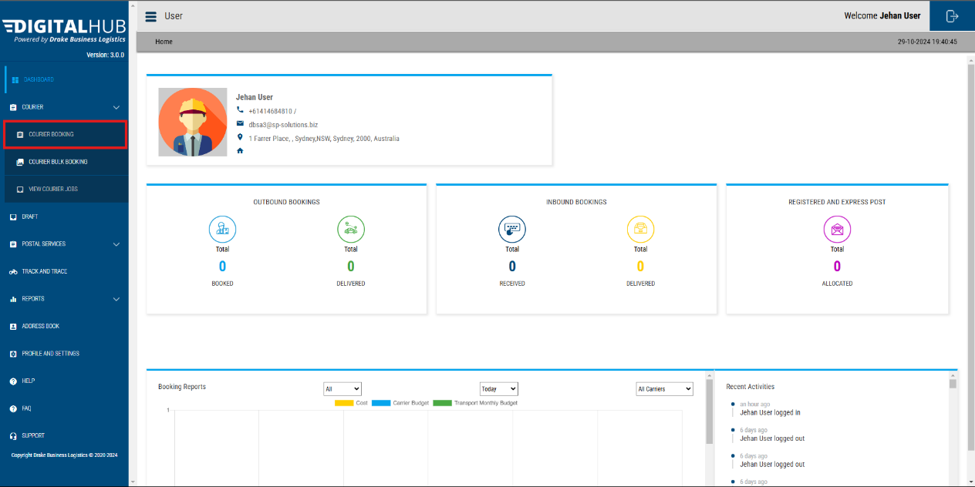And open **‘Courier Booking’** page.

Below booking page will open up.

Then fill in the **delivery address.**

You can fill in the delivery details using the **Address Books.**

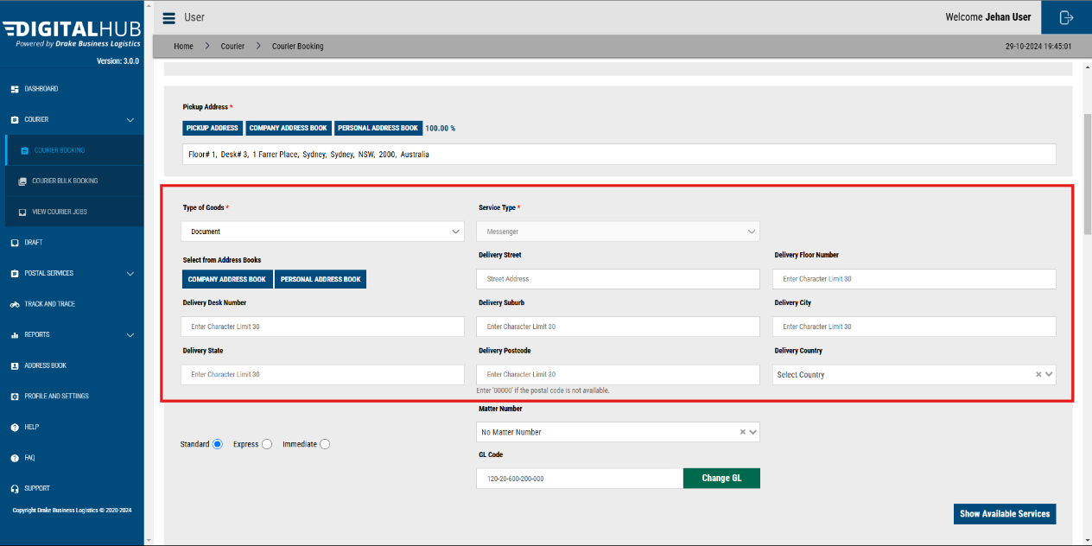

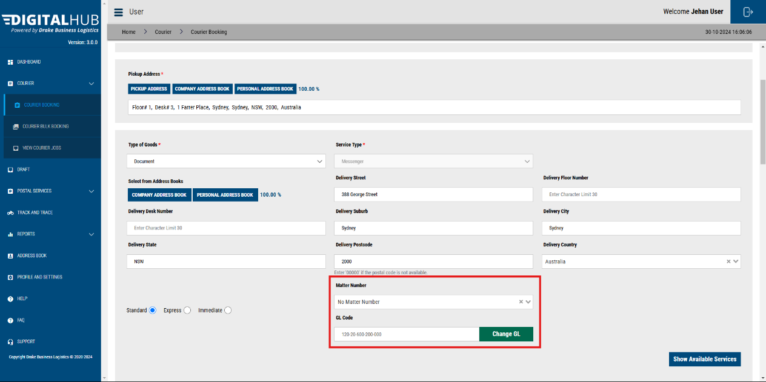Then make sure your **Matter Number** or the **GL Code** is added & is correct.

Then click on the **‘Show Available Services’** button. This will give you a list of available courier services.

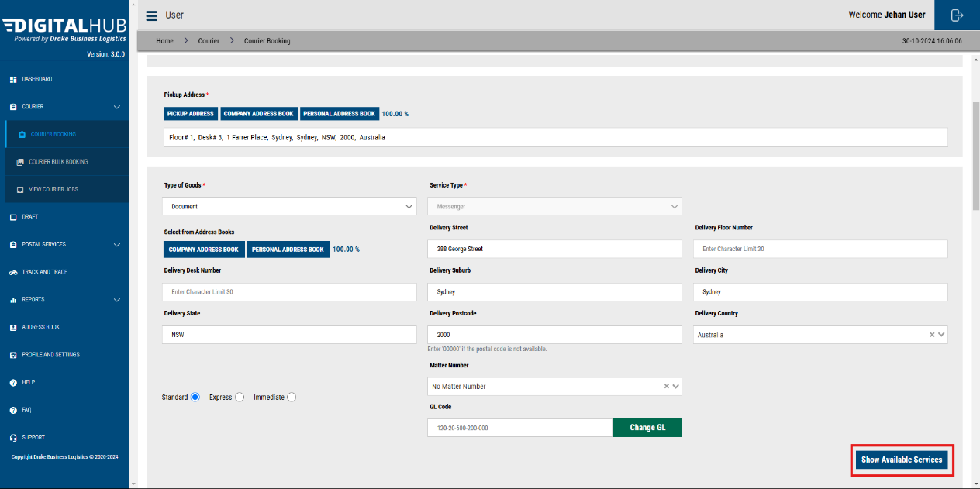

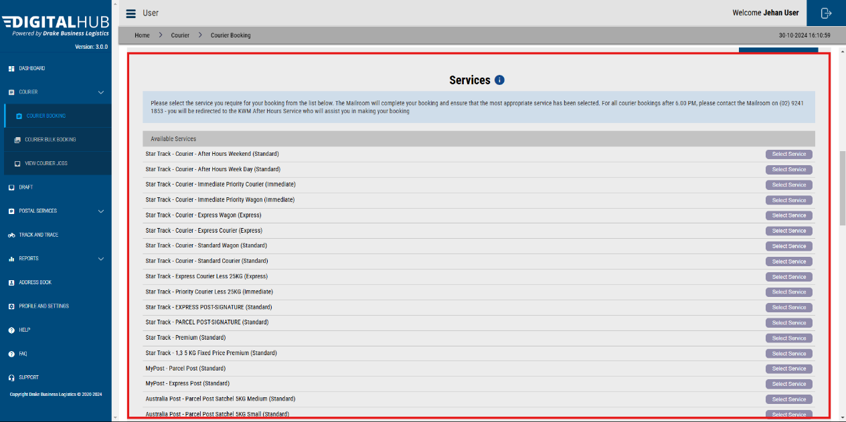

You can choose the preferred service and select it. *This will be shown to the Mailroom operator when processing the booking.*

And scroll down.

Then fill in the missing fields in the delivery address such as ***Full Name, Company Name, Phone Numbers etc.***

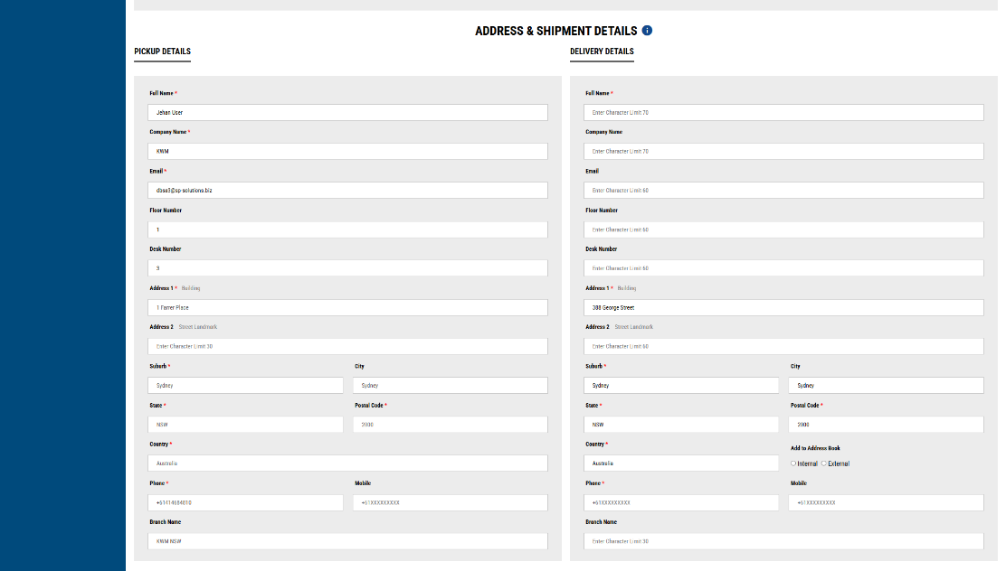

Then add the **Pick up date and Time**, this should always be a date and time in the future.

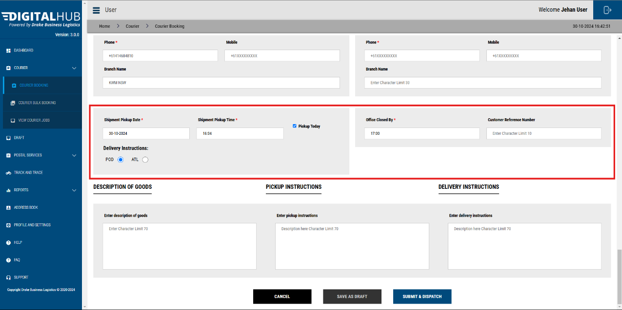

You can then choose between **POD ( Proof of delivery/ Signature on Delivery) verses ATL ( Authority to Leave)**.

Default value of this will the **POD**.

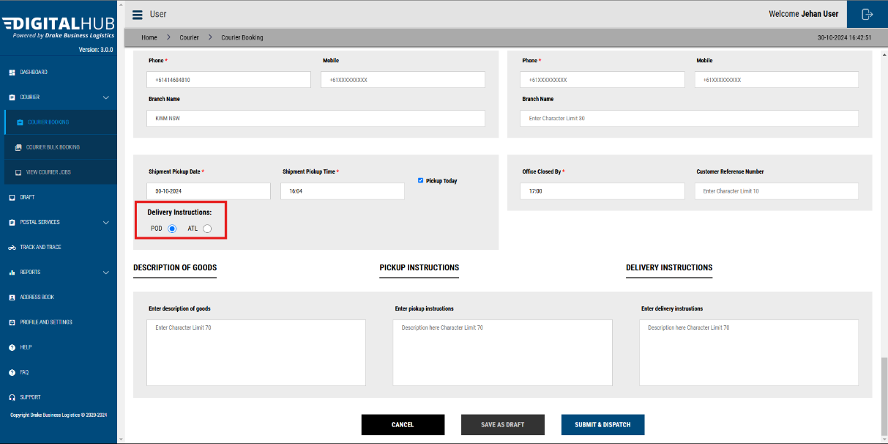

Then add any instructions if you wish. Comments/ Instructions can be added under 3 categories;

* Description of Goods
* Pick-up Instructions
* Delivery Instructions

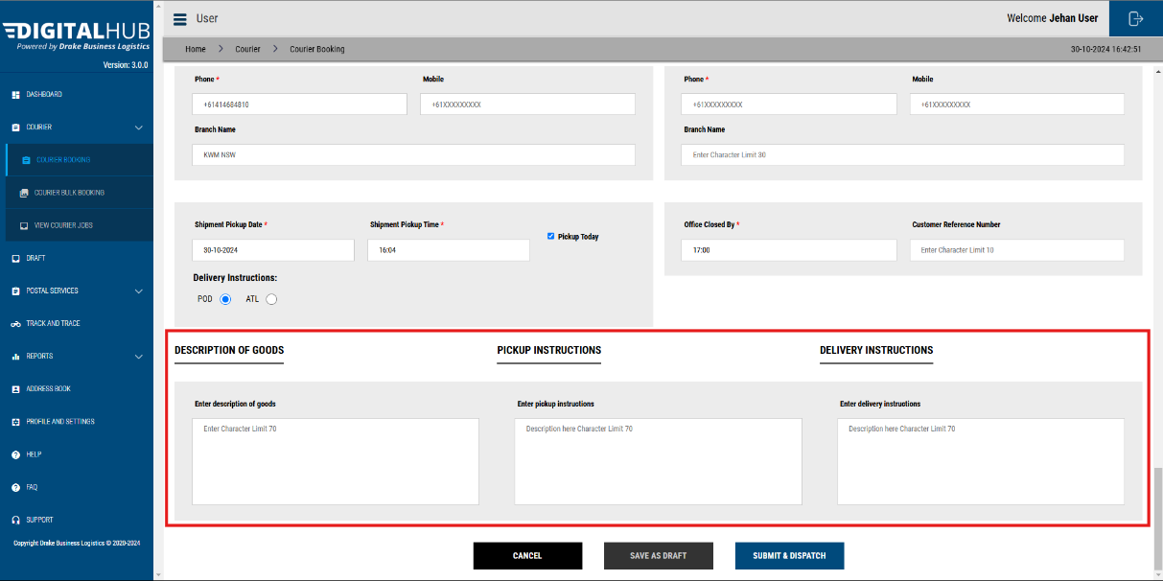

Then, click on **‘SUBMIT & DISPATCH’** button.

This will submit the booking, and a mailroom operator will handle the booking.

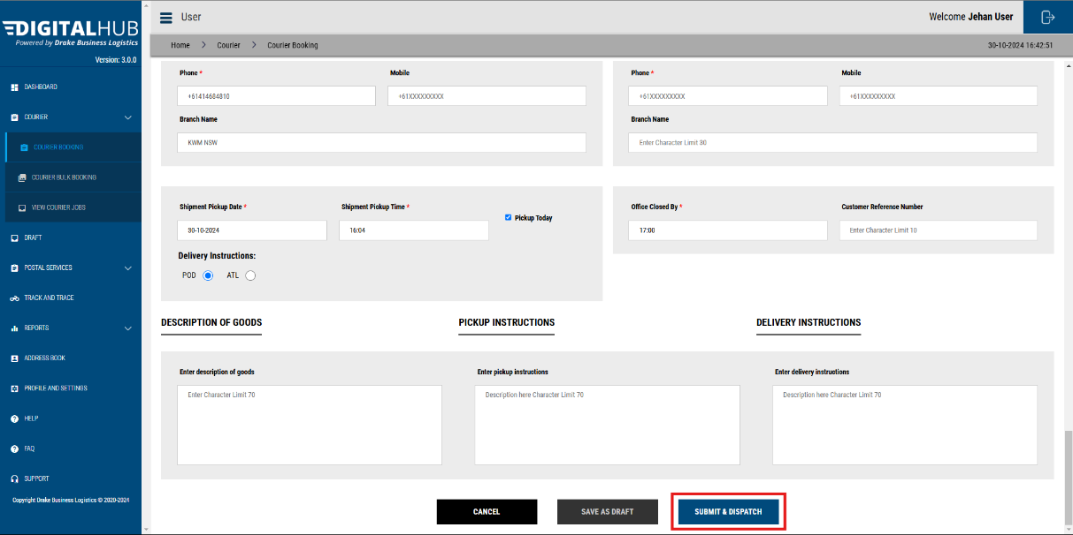

## Save as a Draft

If you wish to amend details later and submit later, you can click on **‘SAVE AS DRAFT’**.

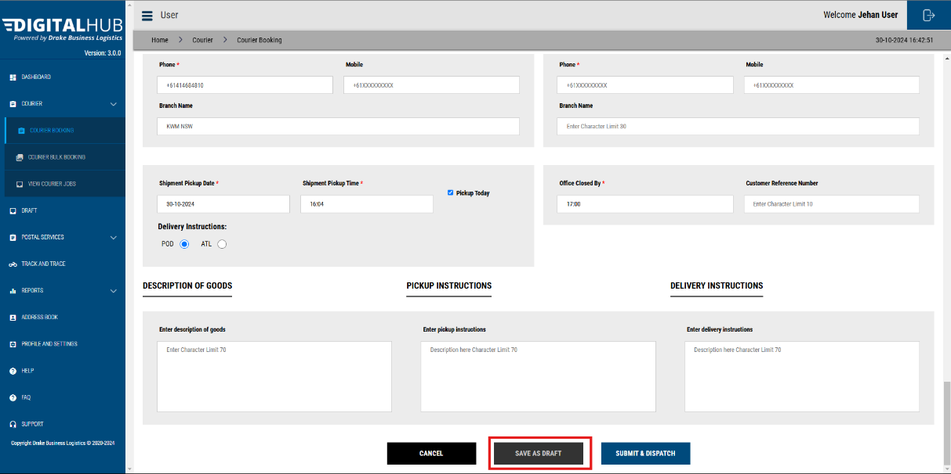

Once saved as a draft you will be able to view the booking in the **DRAFT** panel.

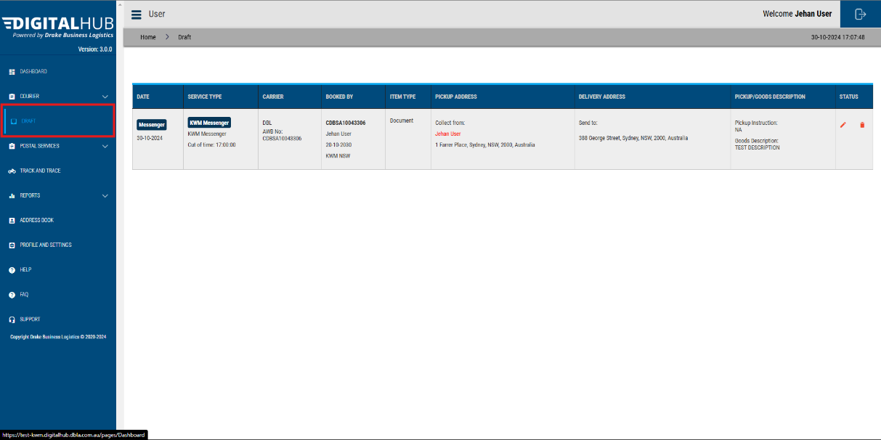

To edit, click on the **Pencil Icon.** Then the booking page will be reopened, & you will be able to continue editing.

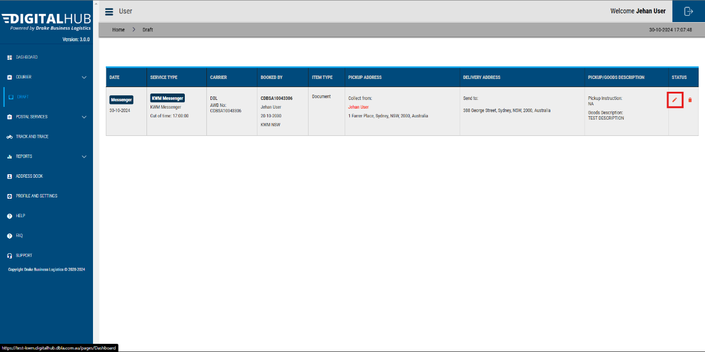

# Label Print

In the **View Booking** page, click on the **EYE** icon & then click on the **Print Label** to print the label.

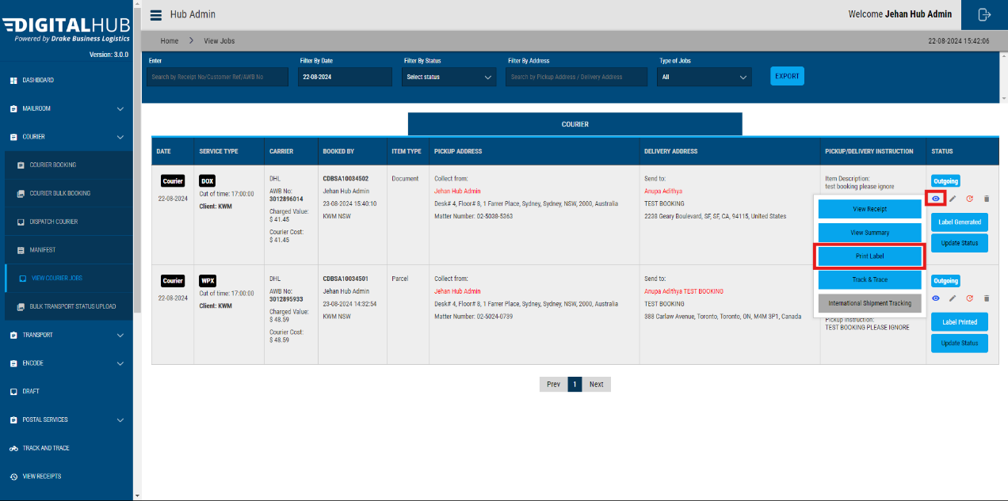

You can print and paste the generated label on the package.

# Tracking progress of your Shipment

You can track the progress of your delivery here:

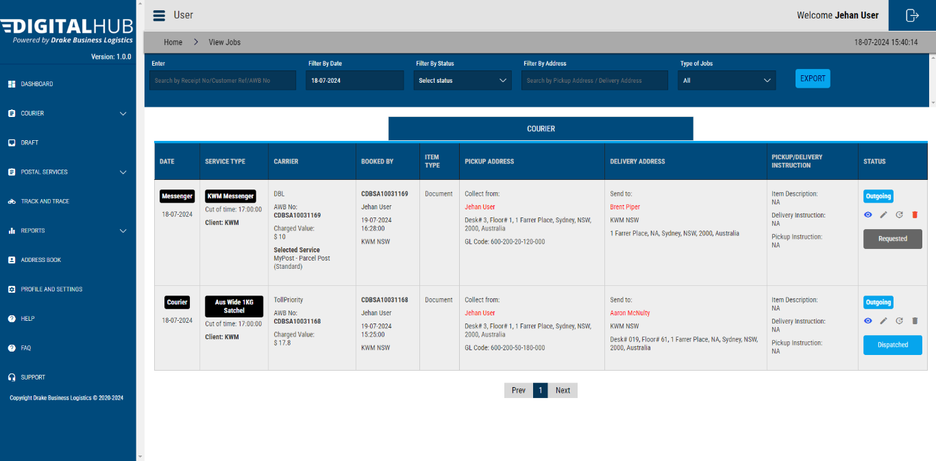

Click on the **EYE** icon

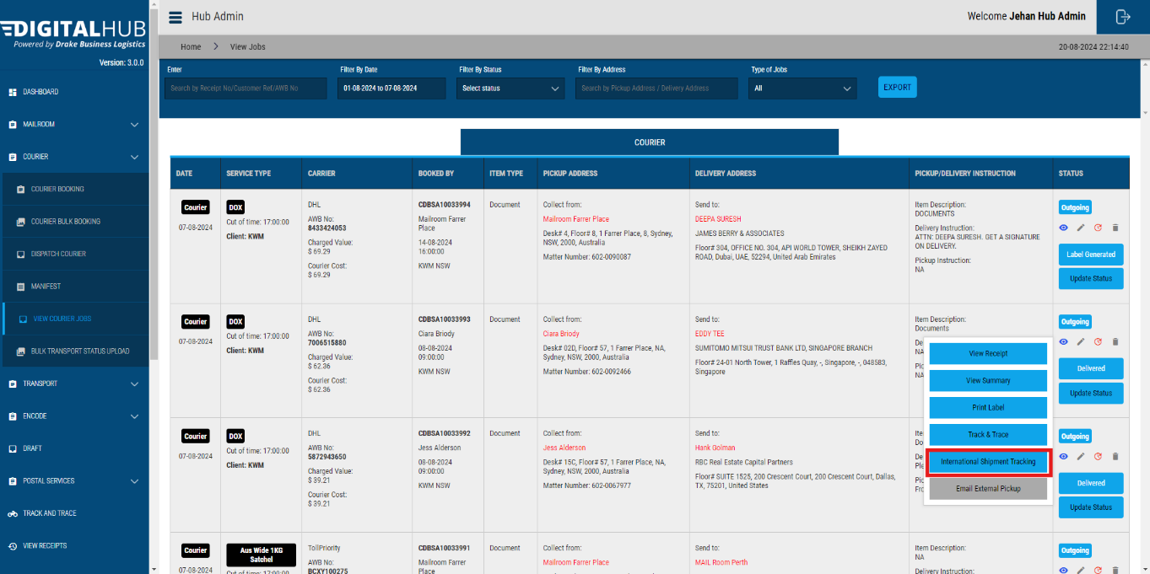

In the popup select **International Shipment Tracking** ifthe booking is through DHL, if not it will display **Courier Shipment Tracking**.

For **DHL, Star Track & Star Track Courier bookings** all tracking event details will be shown in the popup.

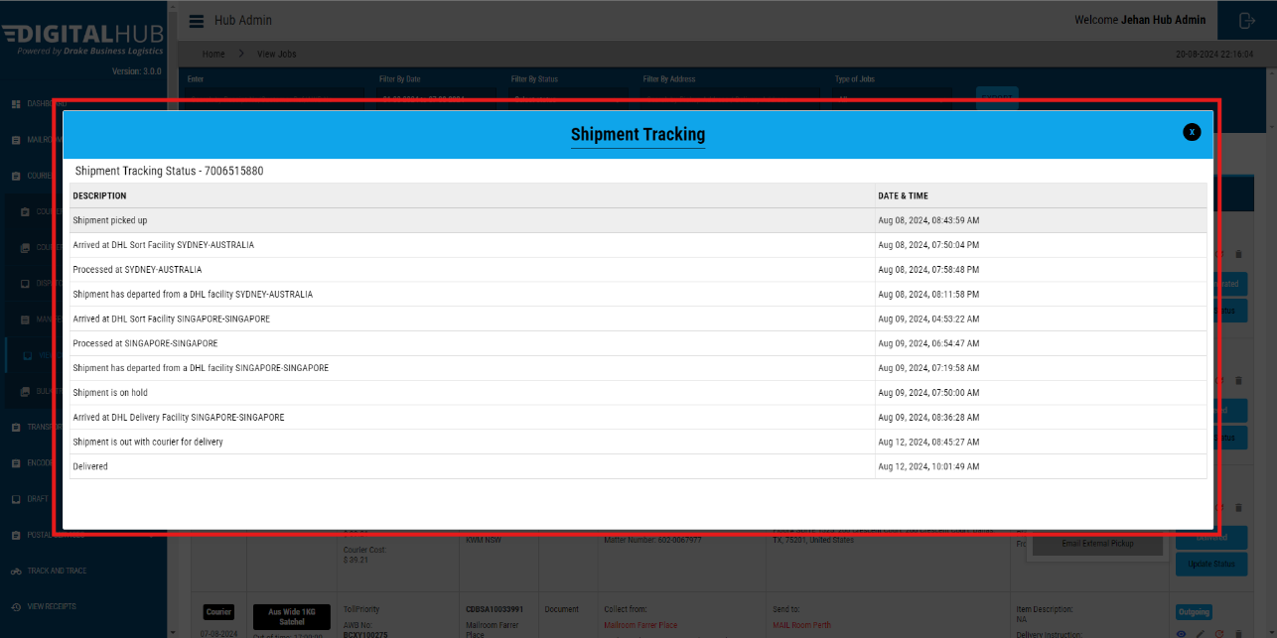

For the other courier services ( Toll Priority, Star Track , & Aus Post) you will be automatically redirected to the courier’s official Tracking page.

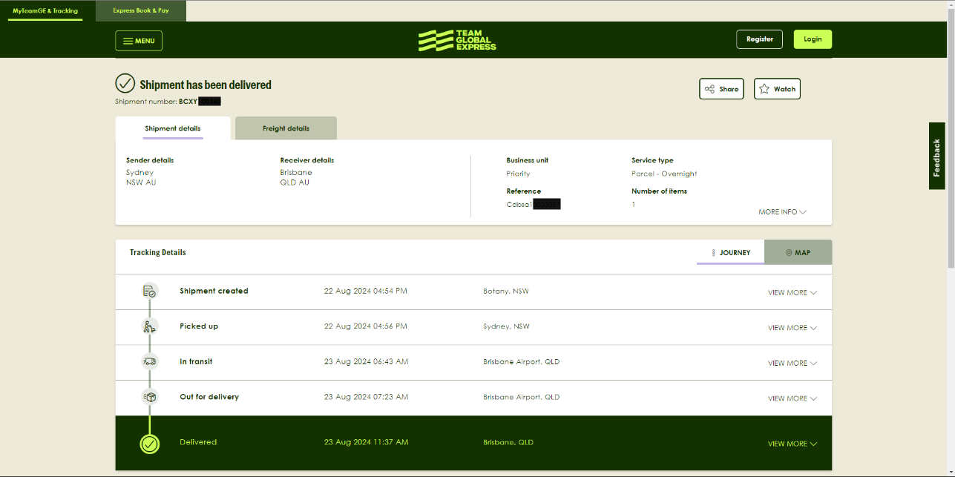

# Processing a User Requested Booking

## Choose bookings to process

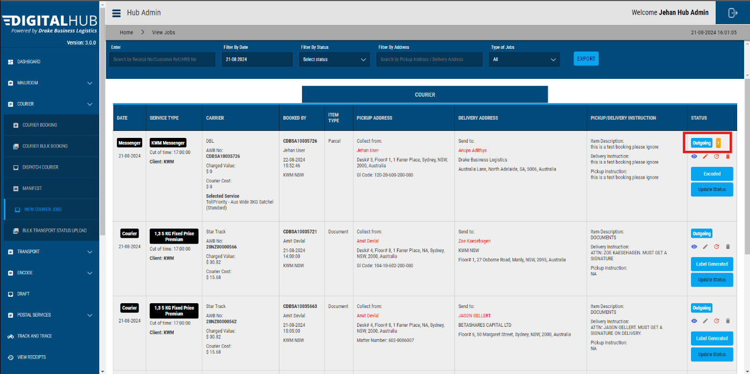

When a user adds a booking, the Hub Admins will be able to view them as shown above. *You can identify them from the yellow exclamation mark.*

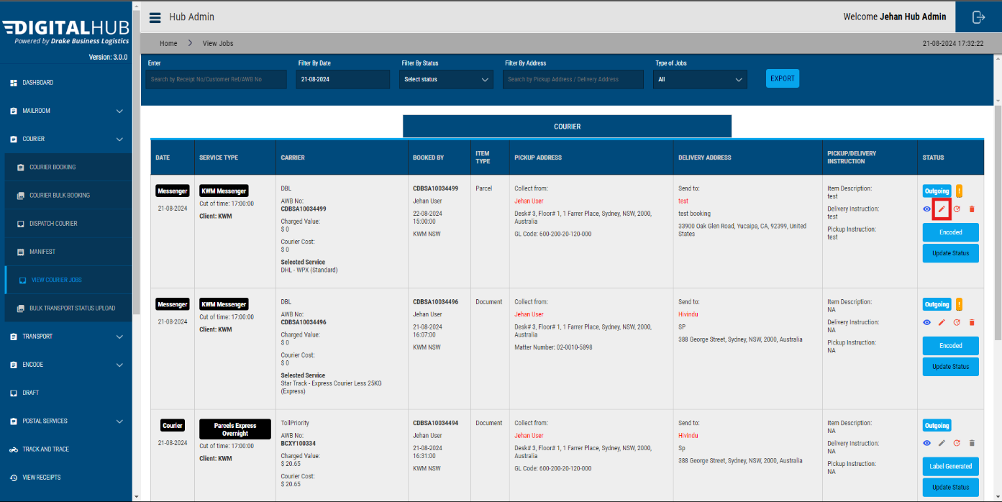

Click on the **Pen** icon to start processing the booking.

Then, the below screen will be opened.

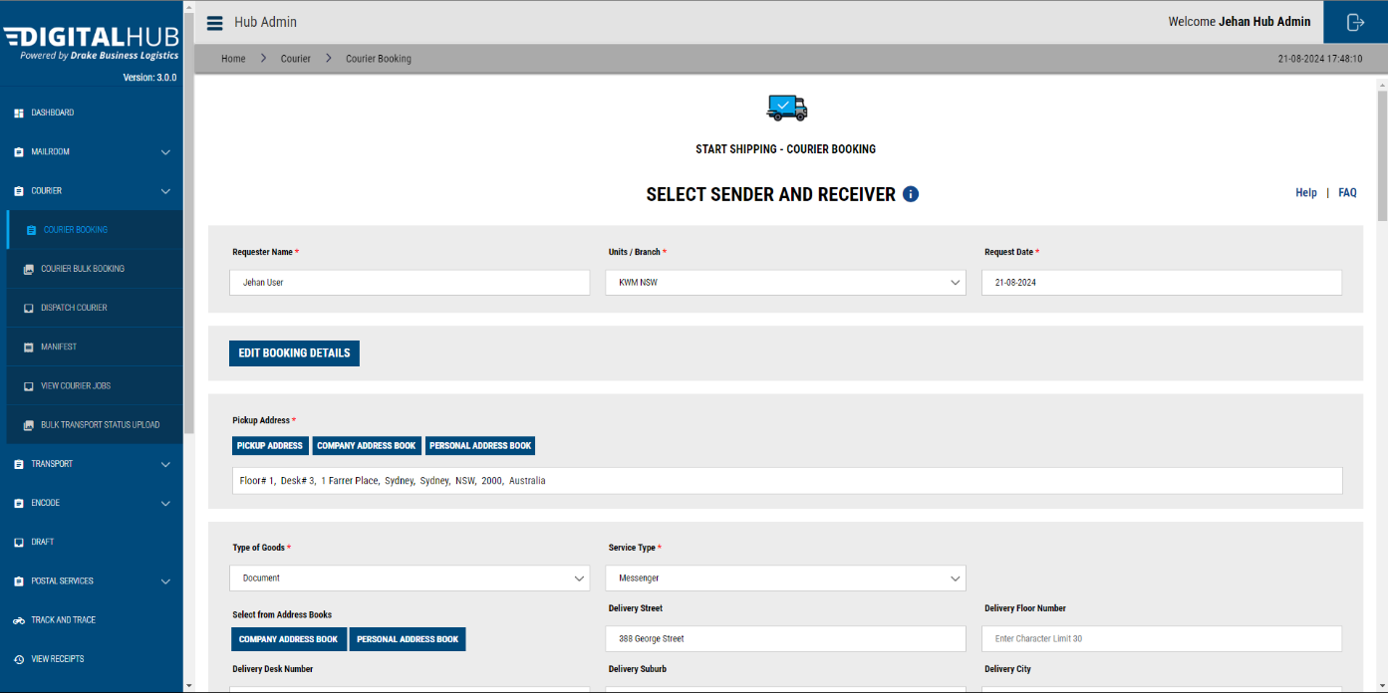

## Edit the booking

Firstly, make sure to select the correct service type. For **DHL** which is **International**.

Then make sure all the address details, Matter number or GL code are added.

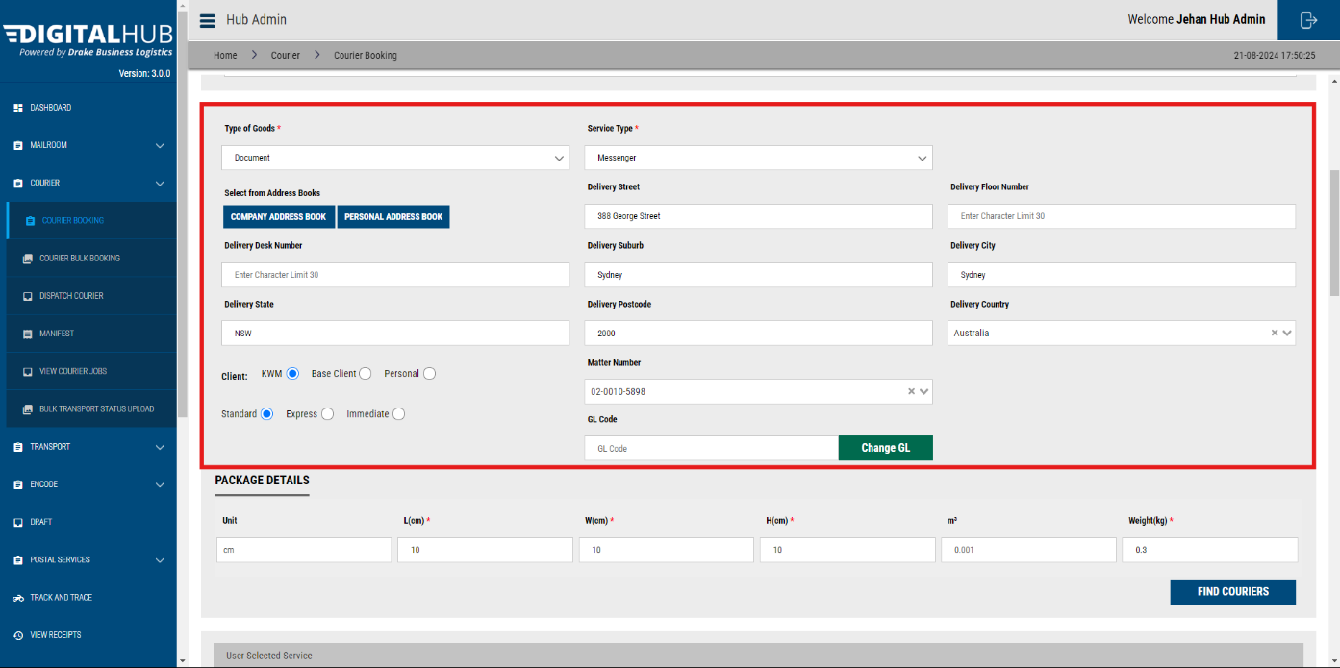

Add the measurements & the weight of the package.

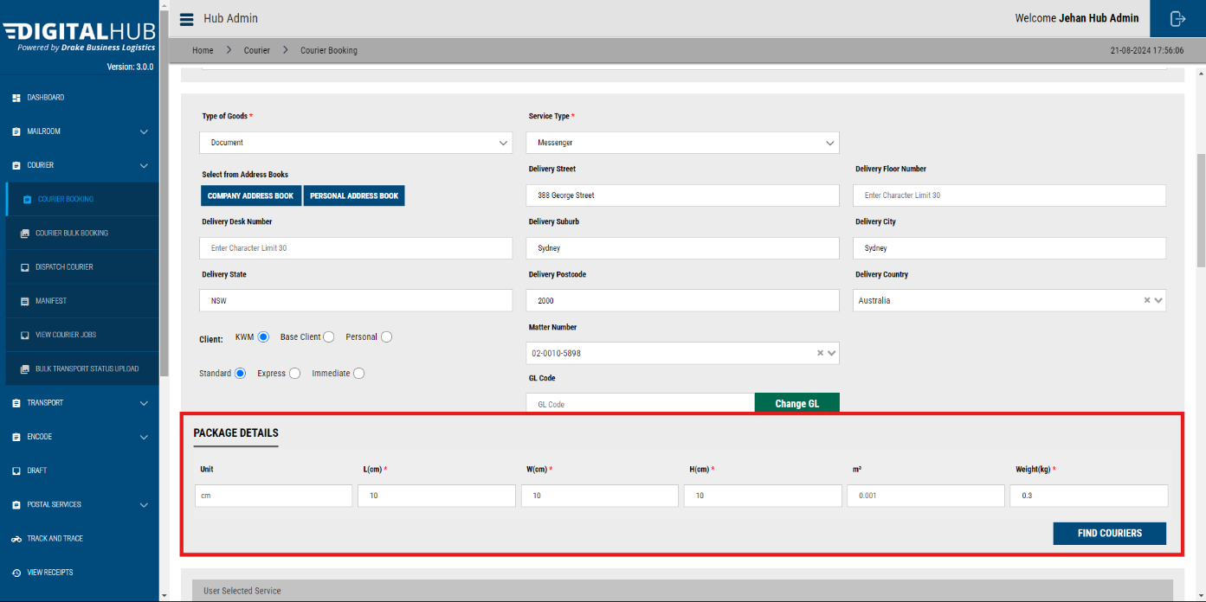

Then Click on **Find Couriers.**

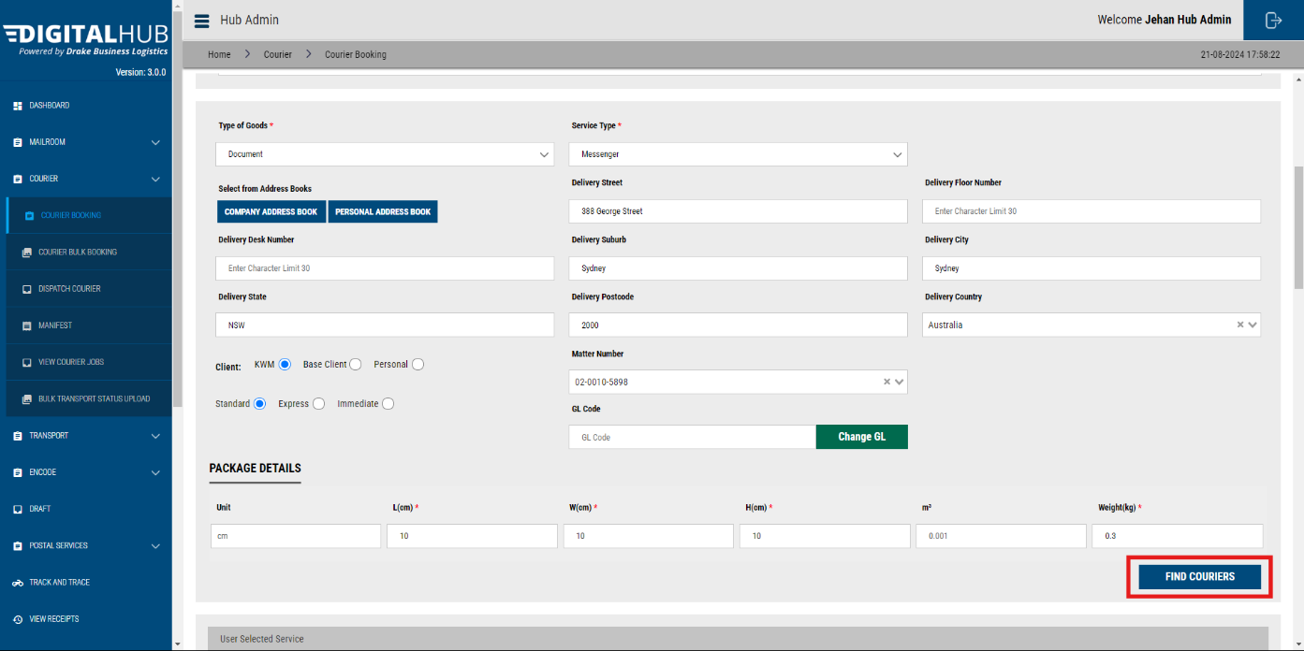

From the services list, select your preferred one. And scroll down.

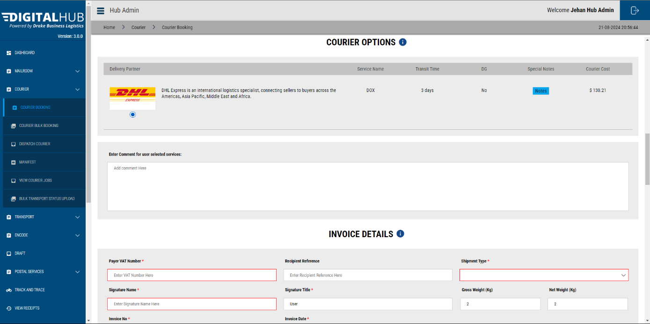

The rest of the processes is the same as creating a new booking.

# Processing a User Requested Booking – Toll/ TGE

## Choose bookings to process



When a user adds a booking, the Hub Admins will be able to view them as shown above. *You can identify them from the yellow exclamation mark.*



Click on the **Pen** icon to start processing the booking.

Then, the below screen will be opened.



## Edit the booking

Firstly, make sure to select the correct service type.

* Domestic
* International

Then make sure all the address details, Matter number or GL code is added.



Add the measurements & the weight of the package.

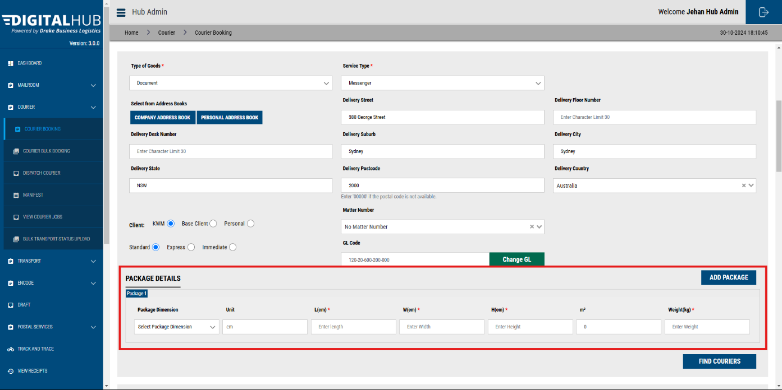



By clicking on the **Package Dimension** dropdown, you will be able to select from a list of frequently used package types. Once selected, dimensions relevant to those packages will auto-populate.

If you need to add a custom weight, please choose **‘Custom’.**

Then Click on **Find Couriers.**

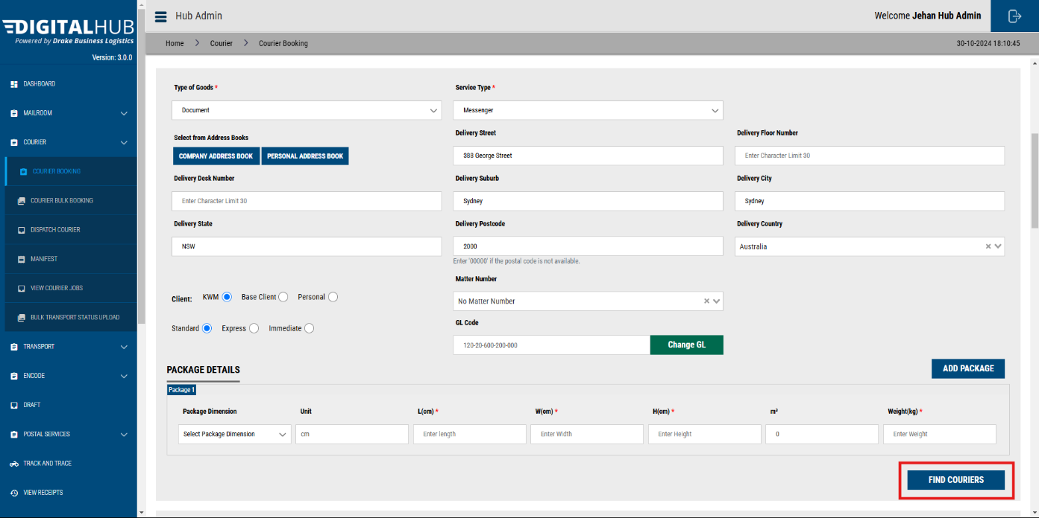

From the services list, select your preferred one. And scroll down.

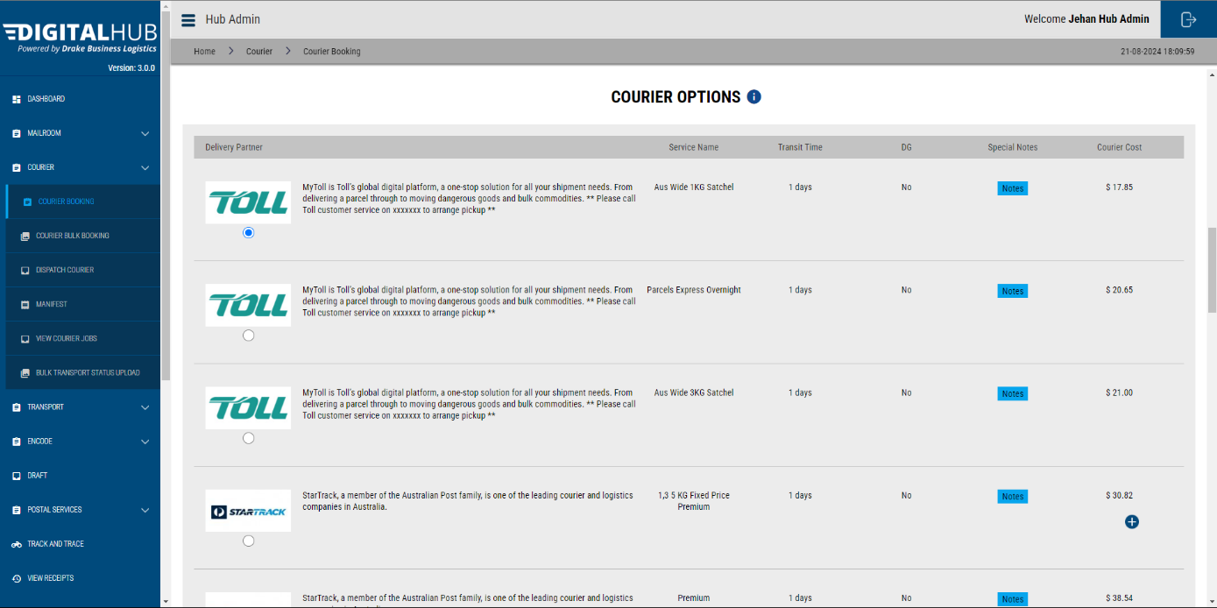

## Address & Shipment Details

Here you need to make sure that the users have added the receivers Name, Company Name, Email, & Phone number.

Address details will be filled in automatically.



## Pick up Time and Date

Update the pickup date, & time.

Additionally, you can add the Office Closing time too.

The user selected **Delivery Instruction** (POD vs ATL) can be seen as well.

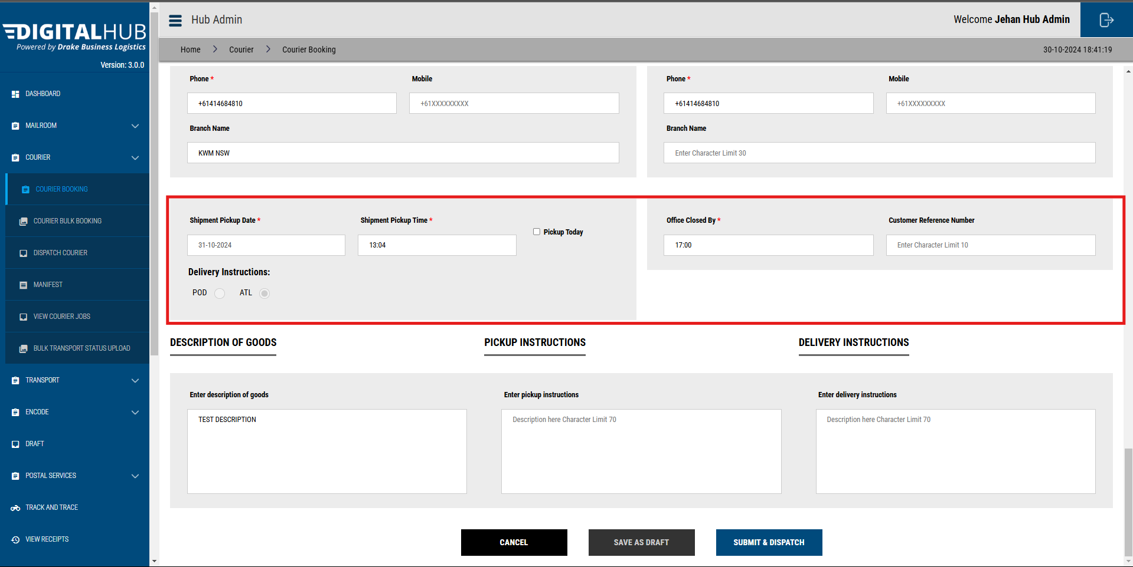

You may add any additional instructions in the given fields. 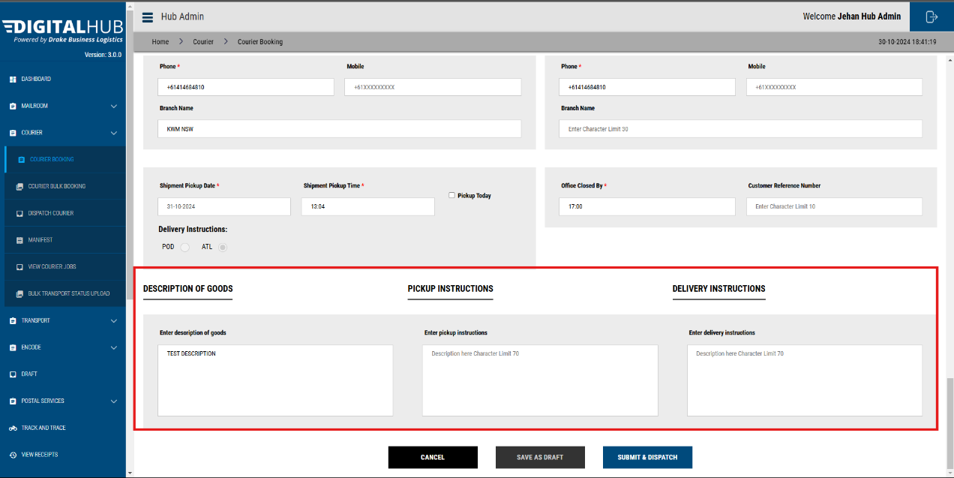

Click **Submit & Dispatch**. Your booking will be created.

You will be redirected to the **View Booking** page.

From here, you can follow the same process to **Print Label, Manifest** & **Print the manifest**.

# Track & Trace

This option allows you to see the track records of the booking, including details such as;

* Person who requested the booking
* Mailroom operator who processed the booking
* Delivery status and related information

On the **View Courier Jobs** page,

Click on the **EYE Icon**

Then click on the **Track & Trace** icon

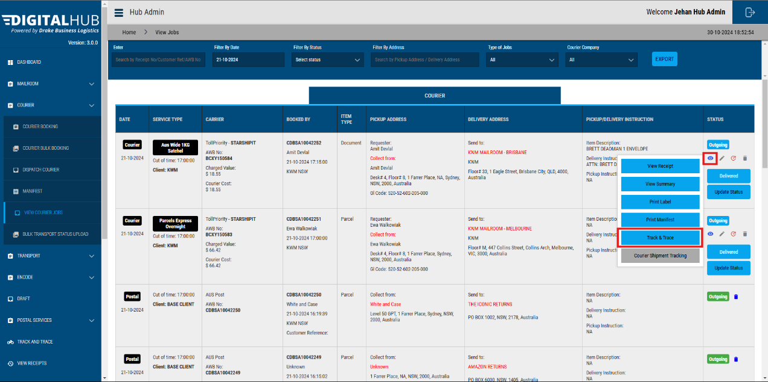

Then the below pop-up will be opened.

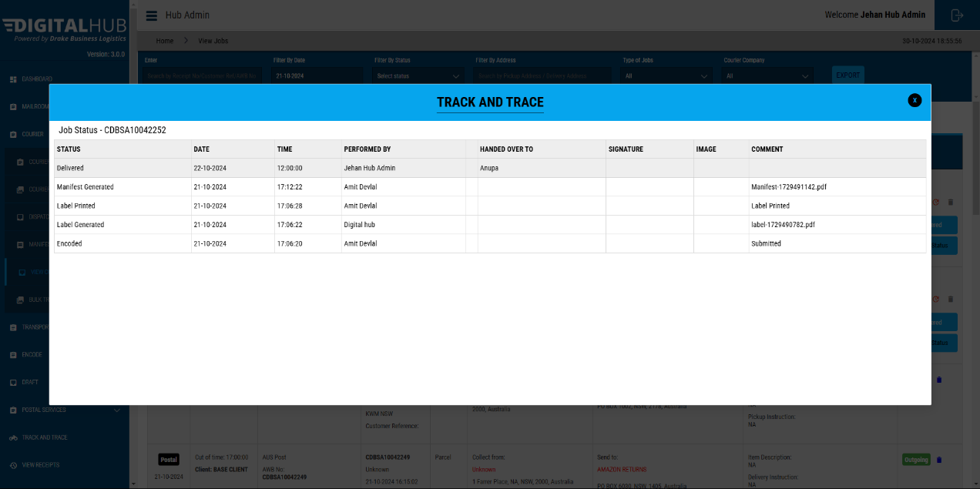

# INVOICE RECON FUNCTION

## Invoice Reconciliation Function

Once logged in to your Digital Hub account, click on the “INVOICE RECONCILIATION” page on the side panel.

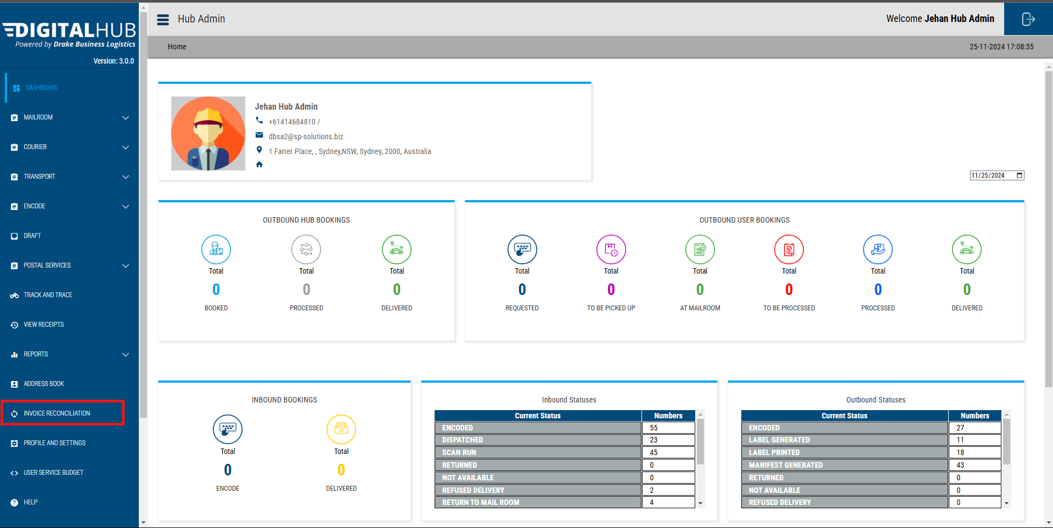

Then you will be redirected to the below page.

### File Upload Validations

For Star Track & Star Track Courier, files need to be in the original name to be successfully uploaded. If the naming template has been changed, the system will reject the file.

Below is the expected naming template for the files.

**Star Track Invoice File**

Electronic Invoice Reporting - Leader Debtor - xxxxxxxx - 2xxx-xx-xx-xx-xx-xx.xlsx

**Star Track Courier Invoice File**

DBLA_WEEKLY_xxxxxxxx.xlsx

### Upload Invoice Files

Click on the dropdown icon and choose the courier company, which you are willing to reconcile the invoice.

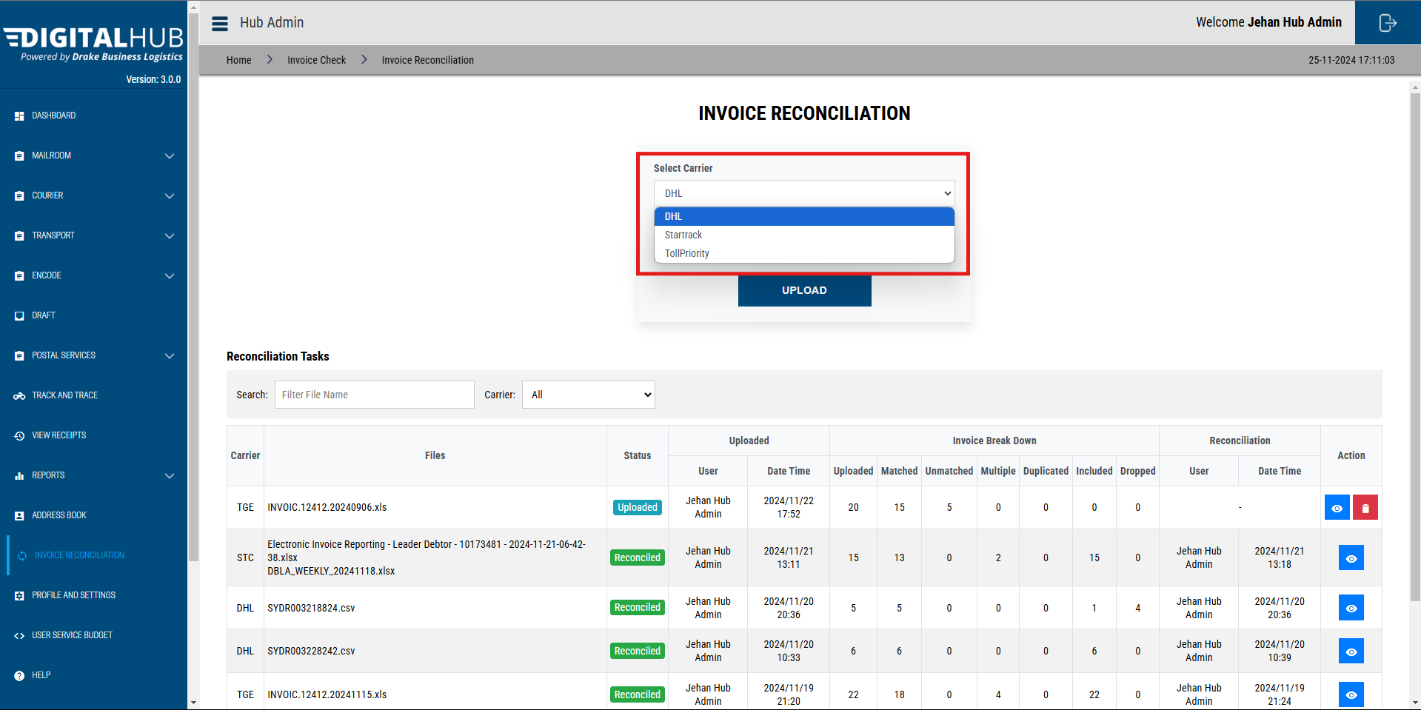

Then click on **“Browse”,** select the correct invoice file and then click on **“Upload”.**

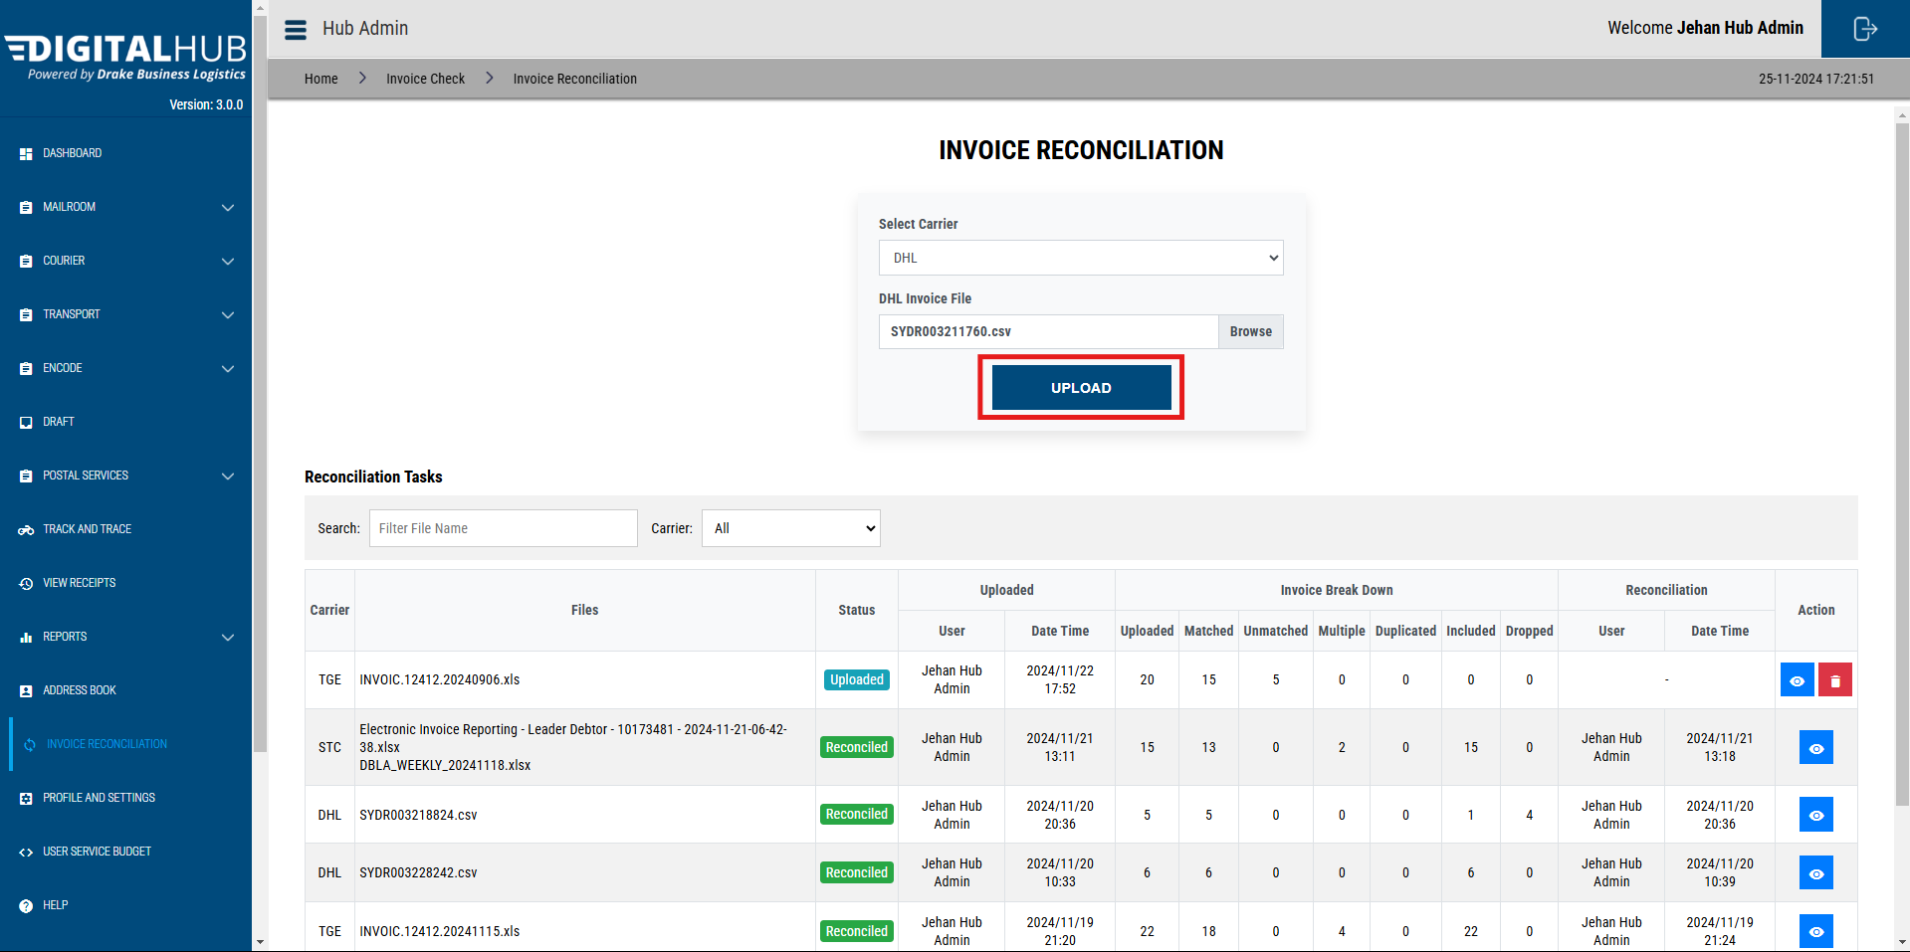

Once clicked, you will be redirected to the below “**Invoice Reconciliation Process**” page.

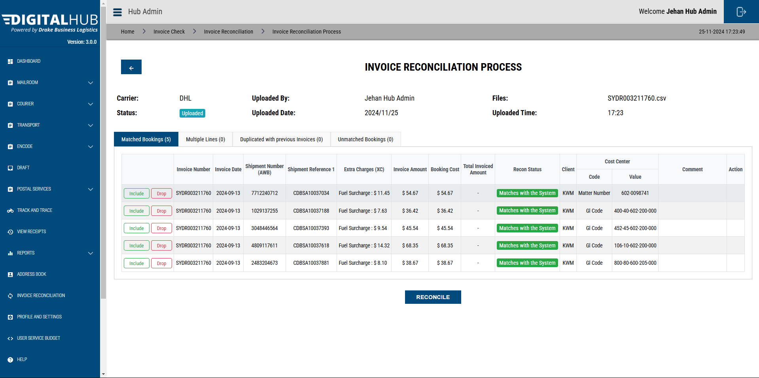

On the first tab, you can see the bookings which are in the uploaded invoice, that match with the bookings in the system.

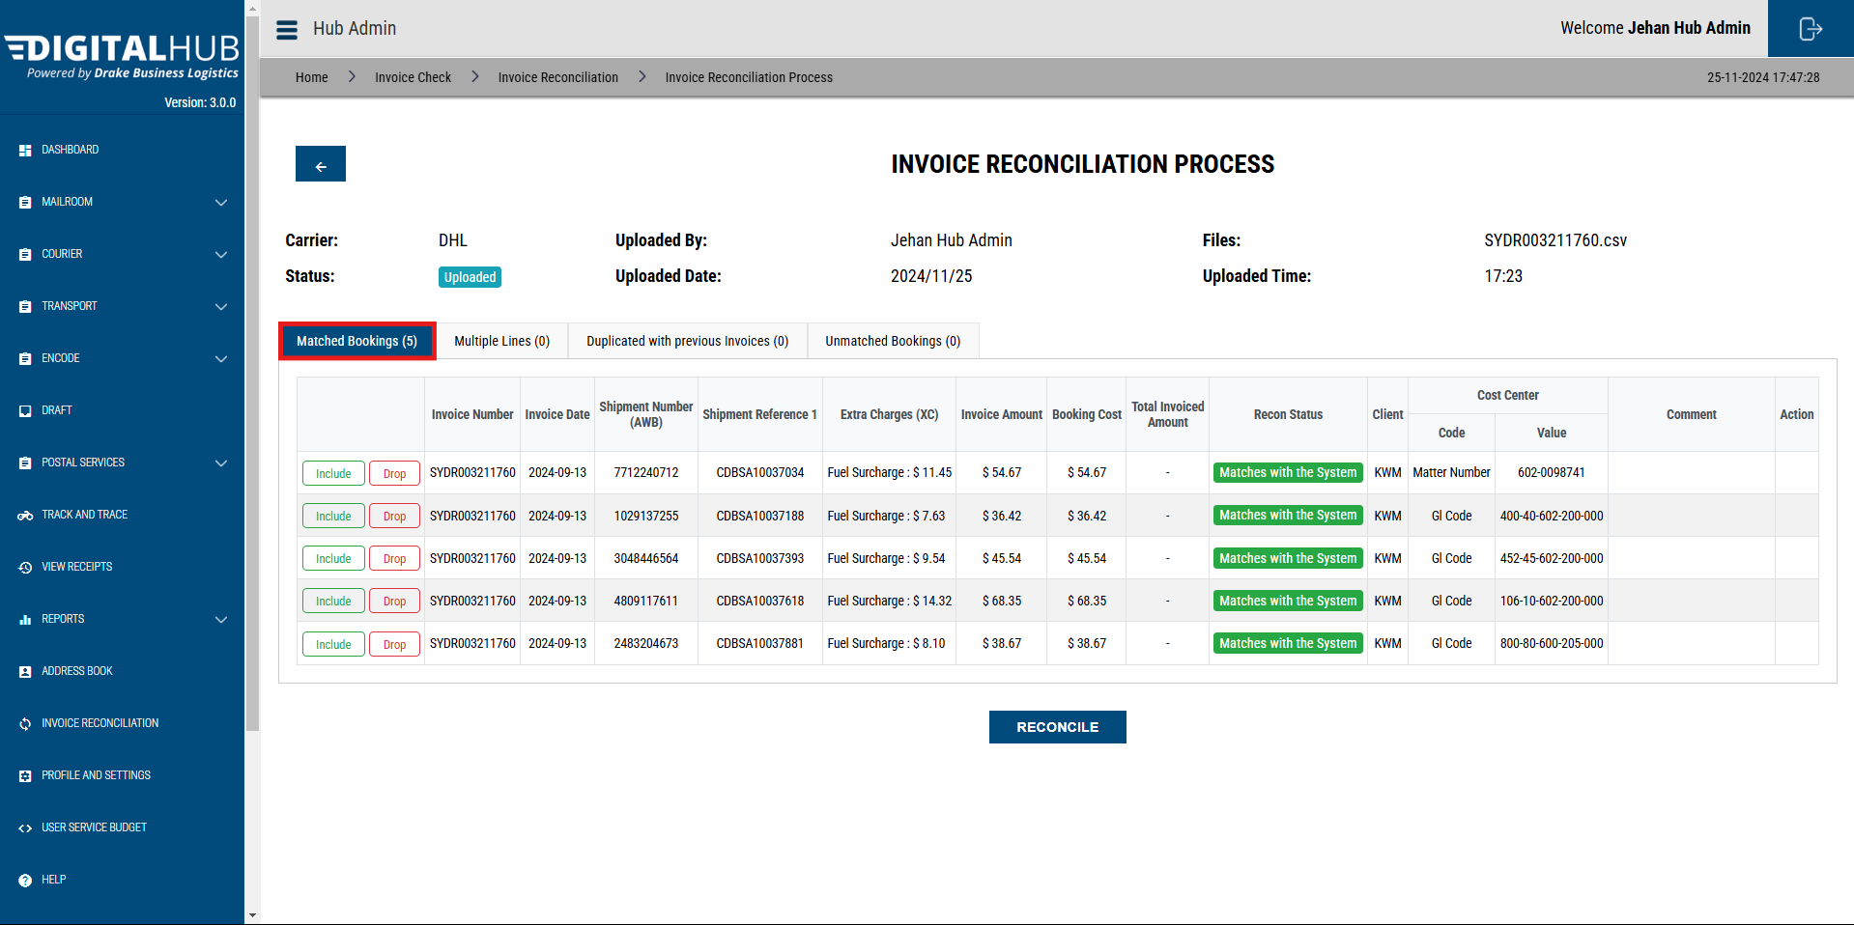

If you wish to reconcile a booking, click on the **“Include”** button**.**

If you wish a record to not be included in the reconciliation file, click on the “**Drop**” button.

If there is a mismatch in the invoice file and the system, amount from the invoice file will be taken as the final cost of a booking.

You can move to another tab, by clicking on them.

### Multiple Lines Tab

This tab contains the bookings which have multiple lines in the same invoice file.

Once included, all the bookings will be shown as one single booking in the reconciliation file, and the amounts will be added together.

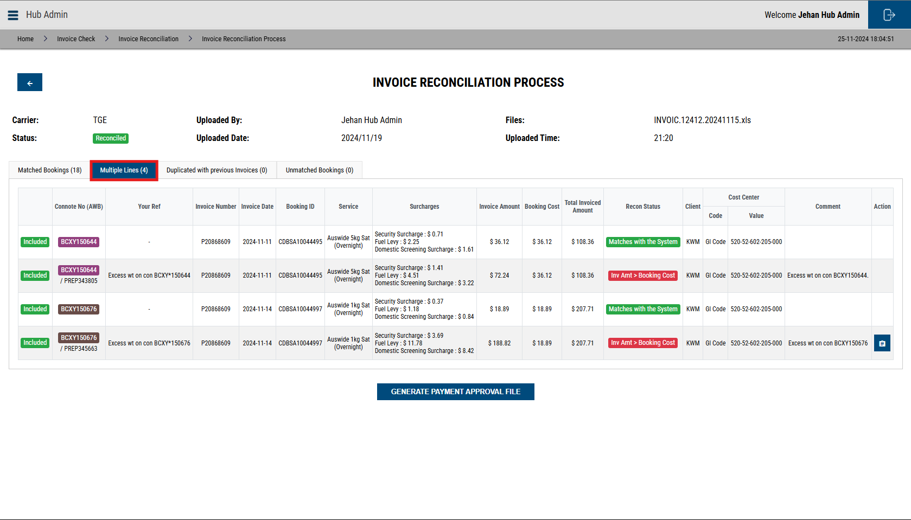

### Duplicated with Previous Invoices Tab

This tab will show the bookings that have been included in previous invoice files & reconciled.

If included the amount in this invoice file will be added to the current amount of the booking & show that total in the invoice

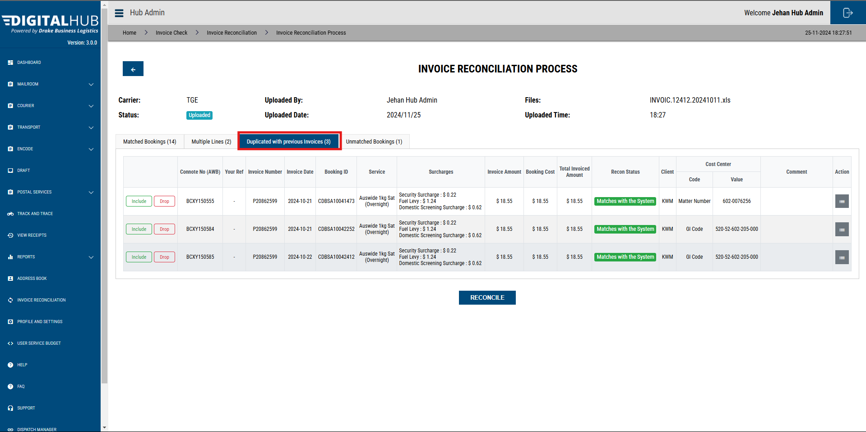

### Unmatched Bookings Tab

This tab will show bookings that are in the invoice file but is not in the Digital Hub system.

If included, relevant information will be shown in the Invoice Reconciliation file.

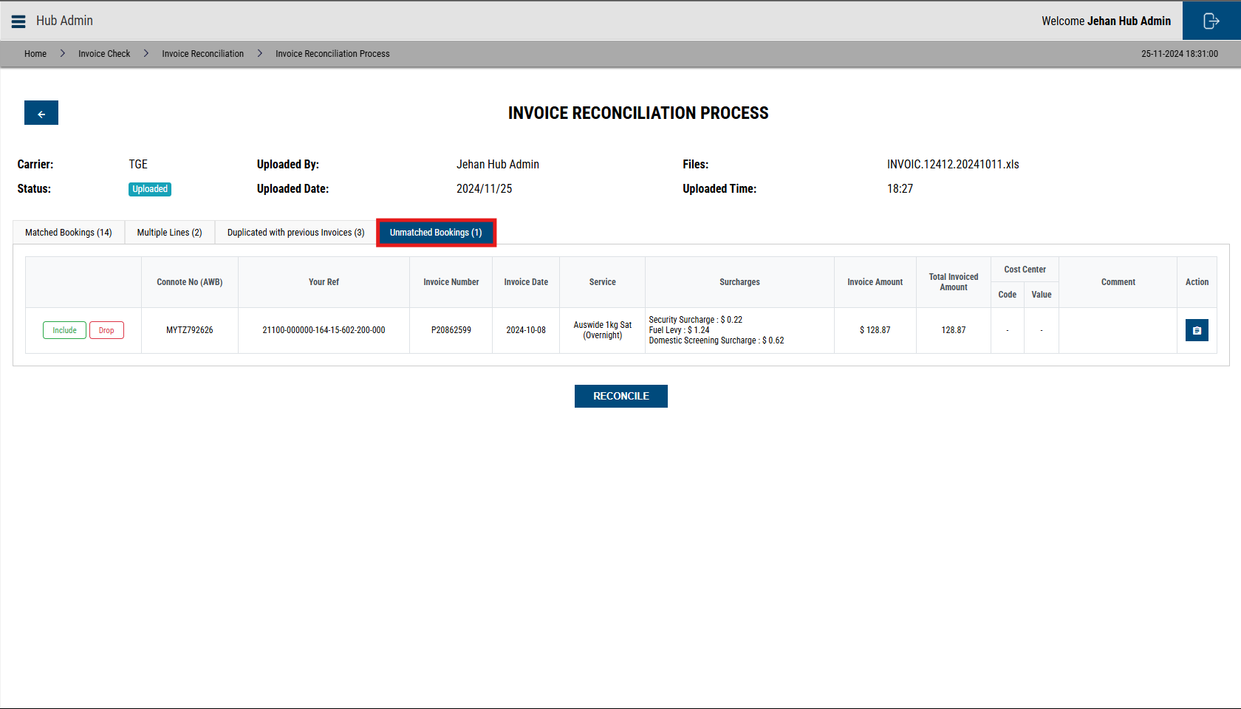

### Reconciling Booking with Amount Mismatches

If the amount does not match in a booking, you will need to add a comment.

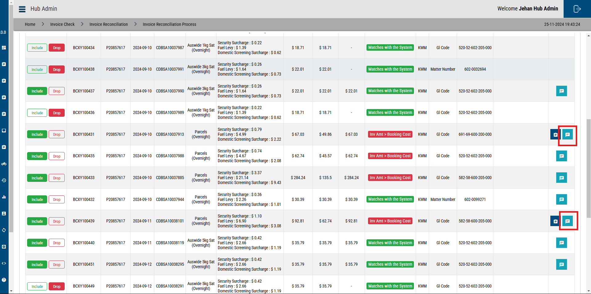

### Reconciling Unmatched Bookings

If you wish to include and reconcile a booking in the invoice, but not in the Digital Hub system, please add a **Cost Center** and **Comment.**

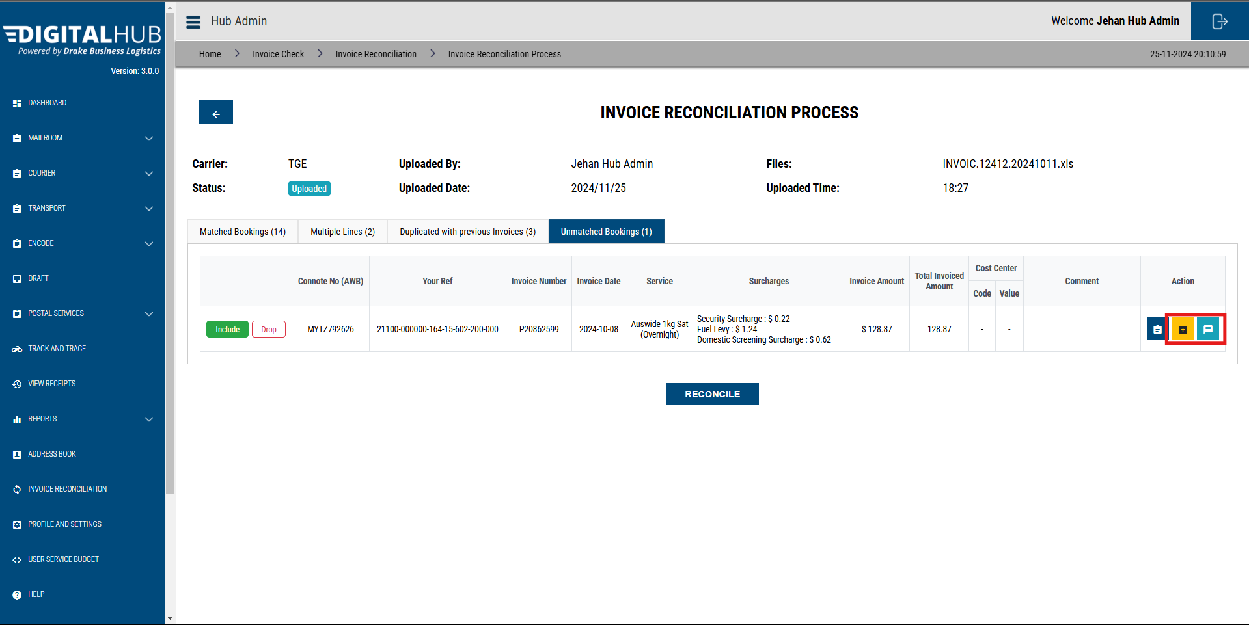

### Reconciliation

To reconcile the files, click on the **“Reconcile”** button on any tab.

All the bookings must be either included or dropped to reconcile.

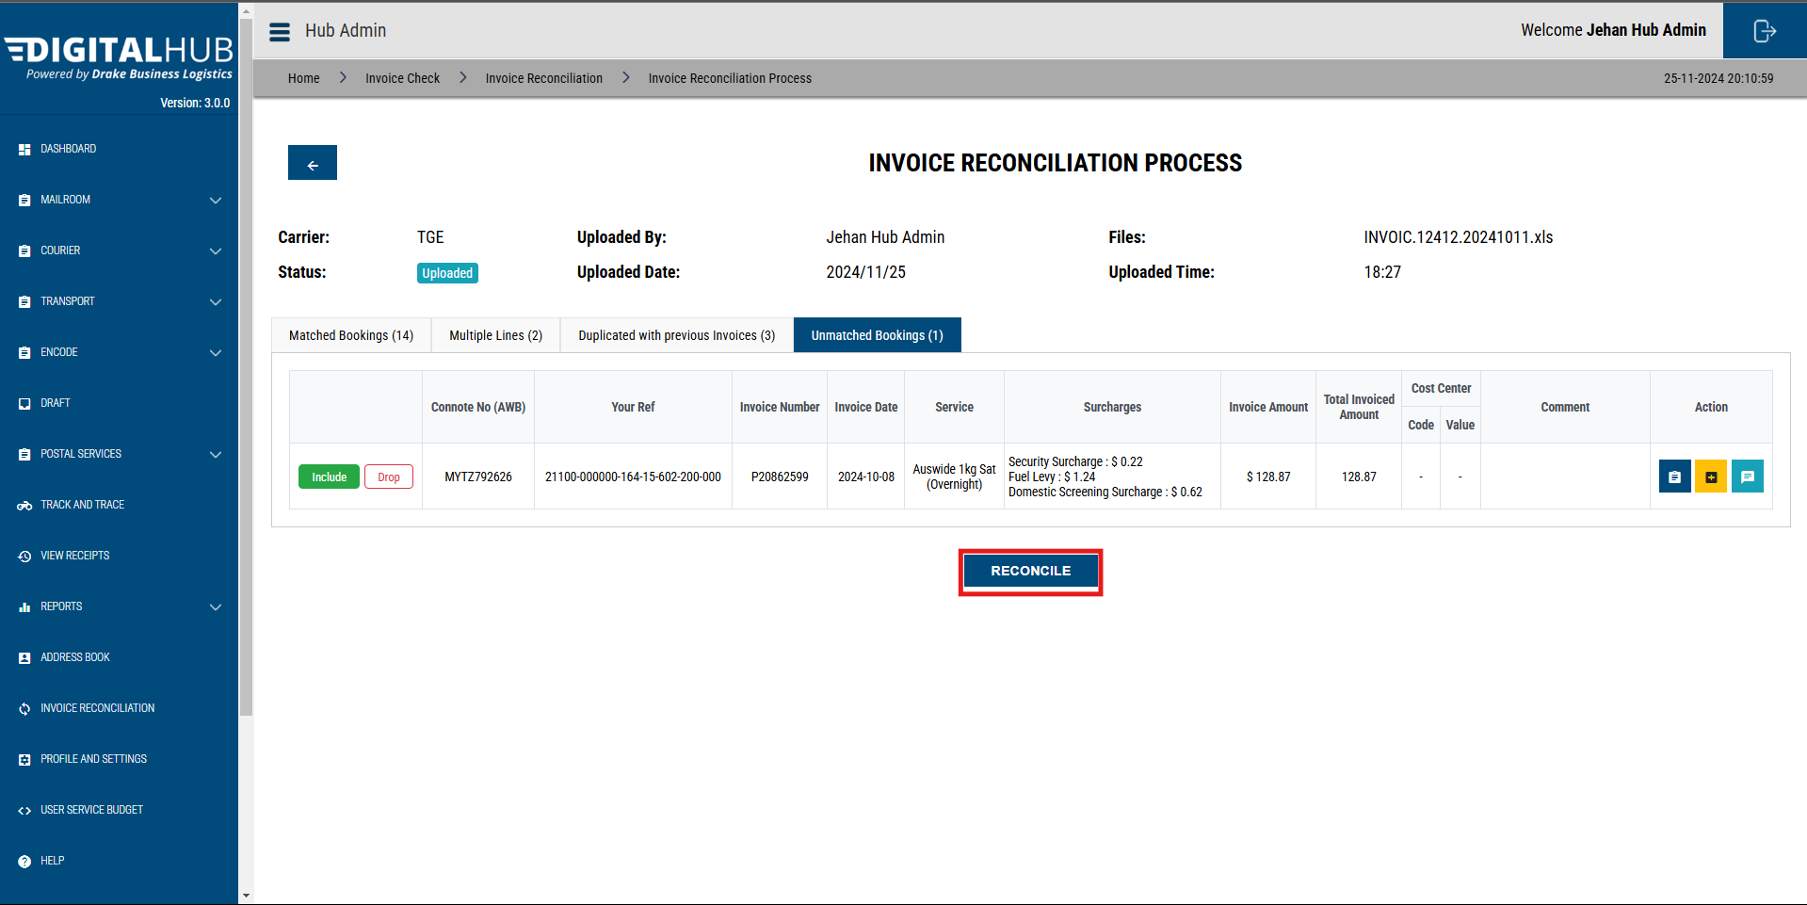

Then, click on the “**Generate Payment Approval File”** button to download the final file.

